SRI SIVASUBRAMANIYA NADAR COLLEGE OF ENGINEERING

(AN AUTONOMOUS INSTITUTION, AFFILIATED TO ANNA UNIVERSITY)
RAJIV GANDHI SALAI (OMR), KALAVAKKAM – 630110.

LABORATORY RECORD

NAME : Sivasarathy A
REG. NO : 3122245001159
DEPT : CSE SEM : V
SRI SIVASUBRAMANIYA NADAR COLLEGE OF ENGINEERING
(AN AUTONOMOUS INSTITUTION, AFFILIATED TO ANNA UNIVERSITY)
RAJIV GANDHI SALAI (OMR), KALAVAKKAM – 630110.

BONAFIDE CERTIFICATE

Certified that this is the bonafide record of the practical work done in the
UCS3568 - Ethical Hacking
Laboratory by
Name : Suganth T
Register Number : 3122245001169
Semester : V
Branch : B.E. Computer Science and Engineering
During the Academic Year : 2026-27

Faculty Head of the Department

Submitted for the End Semester Practical Examination held at SSNCE on
_____________.

Internal Examiner External Examiner
INDEX

NAME: Sivasarathy A REG. NO: 3122245001159
SEM: V
S. No | Date | Experiment | Page No | Signature
1 | 08/07/2026 | Lab Setup: Install Kali Linux & Metasploitable  [Ex 1 to 4] | 4
2 | 22/07/2026 | Practice the basics of reconnaissance (Sysmon, theHarvester, WHOIS, Netdiscover)  [Ex 5,6,8,9] | 7
3 | 29/07/2026 | Information gathering using Nmap  [Ex 16] | 12
4 | 05/08/2026 | Open Source Intelligence using FOCA / Google Dorking  [Ex 7] | 15
5 | 12/08/2026 | Aggregates information from public databases using Maltego and Shodan  [Ex 13,14] | 18
6 | 19/08/2026 | Information gathering using Robtex  [Ex 29] | 22
7 | 26/08/2026 | Scan the target using Nessus  [Ex 23] | 25
8 | 02/09/2026 | Automate attack discovery and match exploits using Armitage  [Ex 28] | 30

Ex. No: 1 Date: 08/07/2026

Lab Setup: Install Kali Linux & Metasploitable
Objective
To configure an isolated ethical-hacking laboratory using Kali Linux and Metasploitable, verify connectivity, perform basic endpoint monitoring, email enumeration and network discovery.
Tools
- Kali Linux
- Metasploitable 2
- Oracle VirtualBox
- Sysmon
- theHarvester
- Netdiscover

Methodology
1. Install and configure Kali Linux and Metasploitable 2 in VirtualBox on the required lab network.
2. Use ip a in Kali Linux and ifconfig / ip a in Metasploitable to identify IP addresses.
3. Verify connectivity using ping <Metasploitable-IP>.
4. Install/configure Sysmon and inspect the Sysmon Operational log in Event Viewer.
5. Use theHarvester on the authorised training domain to collect publicly available information.
6. Run sudo netdiscover to discover active hosts and their IP/MAC addresses.

Procedure Summary
Kali Linux and Metasploitable 2 were installed as guest virtual machines in Oracle VirtualBox on a shared Host-only network, allowing the attacker and target machines to communicate in isolation from the host network.
$ ip a
$ ping <Metasploitable-IP>
$ sysmon.exe -i
$ theHarvester -d <domain> -b all
$ sudo netdiscover -r <network>/24

Screenshots
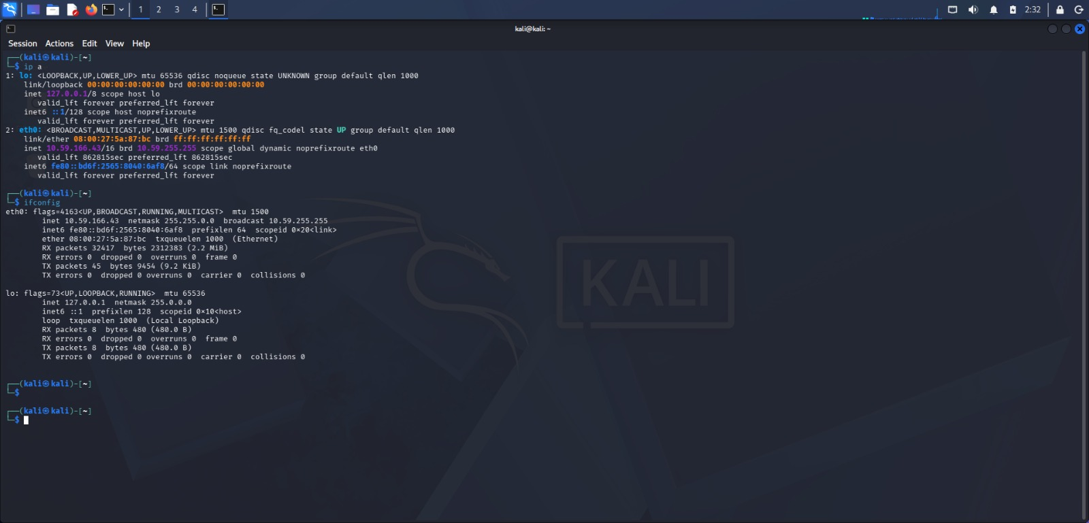
ip a and ifconfig output on Kali Linux — eth0 has IP address 10.59.166.43/16
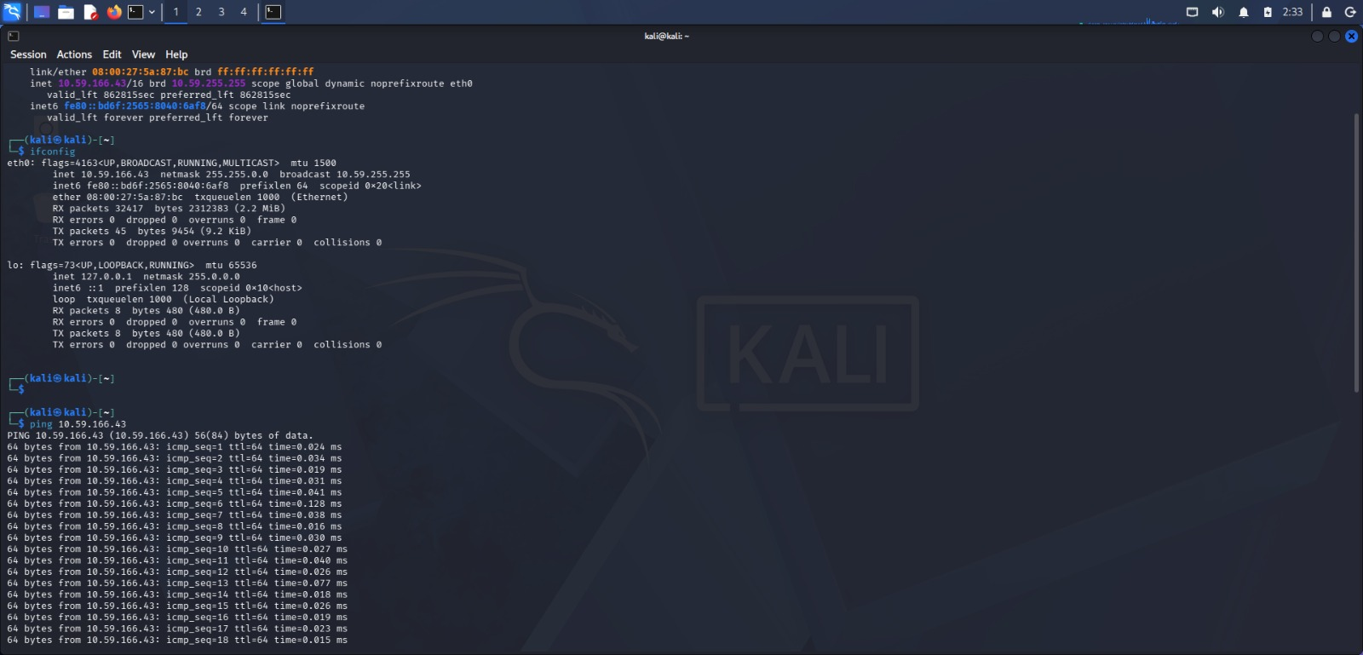
ifconfig output on eth0 (10.59.166.43) followed by ping 10.59.166.43 to verify connectivity
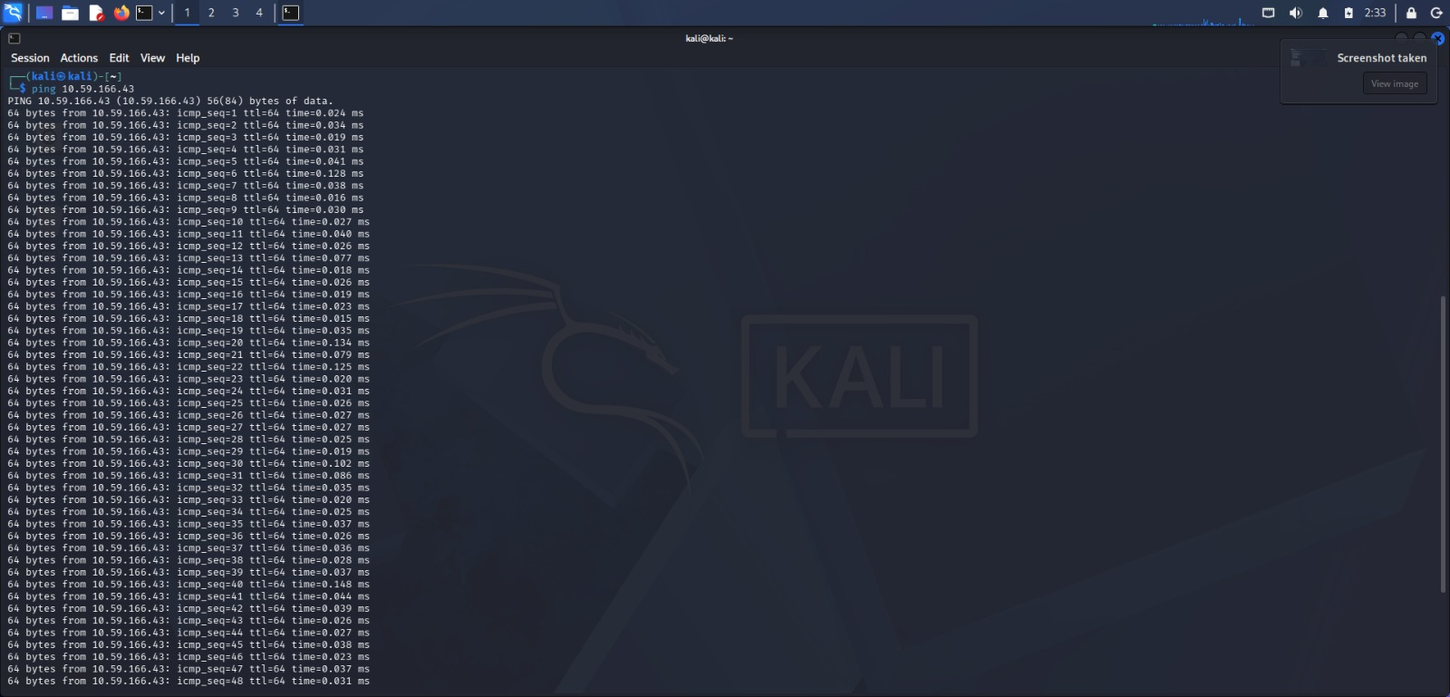
ping 10.59.166.43 in progress — continuous ICMP replies (ttl=64) from the target
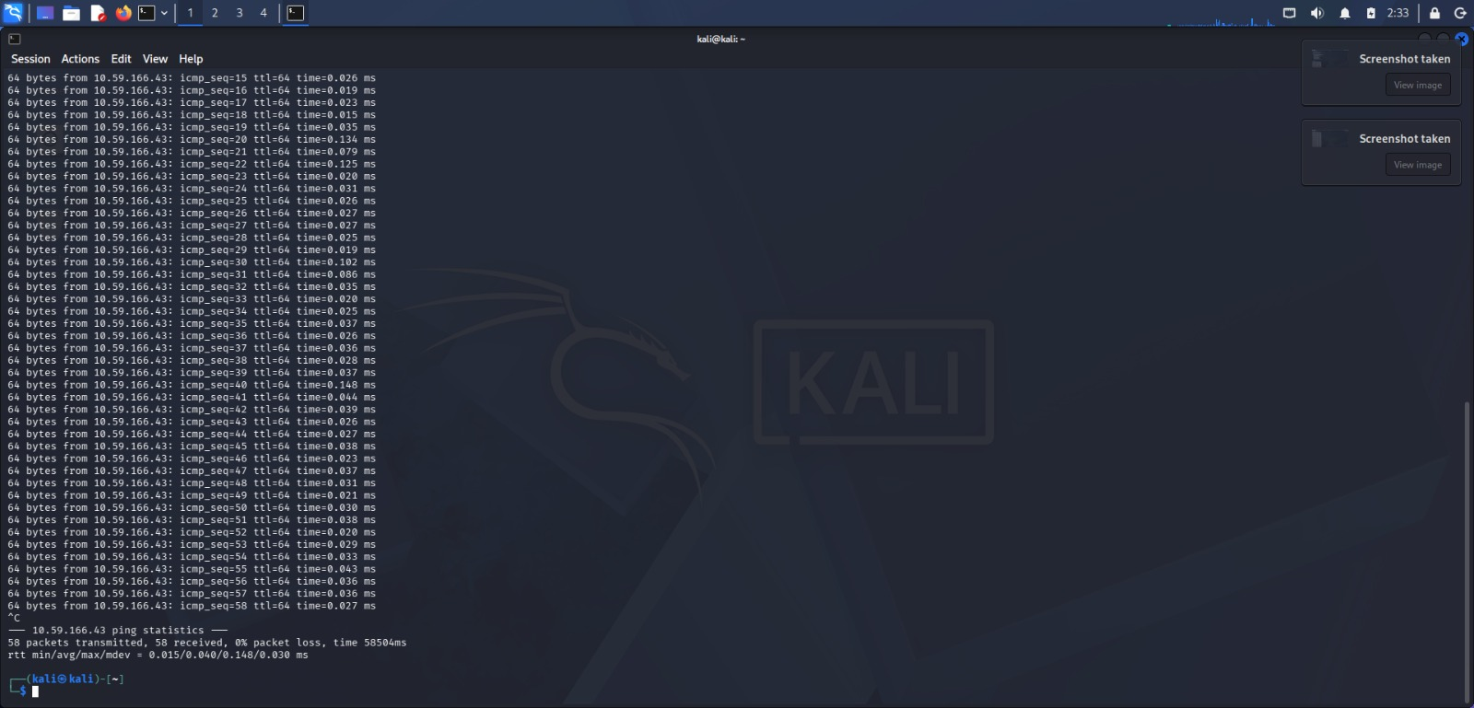
ping statistics — 58 packets transmitted, 58 received, 0% packet loss

Result / Learning Outcomes
- Learnt to configure and verify an ethical-hacking lab using Kali Linux and Metasploitable.
- Learnt to monitor endpoint activity and gather publicly available information using Sysmon and theHarvester.
- Learnt to discover active network hosts using Netdiscover.
Ex. No: 2 Date: 22/07/2026

Practice the Basics of Reconnaissance
Objective
To perform reconnaissance and system monitoring using Sysmon, theHarvester, WHOIS, and Netdiscover, collecting information about systems, domains and networks, and identifying active devices and publicly available information for cybersecurity analysis.
Tools
- Sysmon
- theHarvester
- WHOIS
- Netdiscover

Methodology
1. Install and configure Sysmon to monitor system activities and generate security event logs.
2. Use theHarvester to gather publicly available information such as email addresses, subdomains, hostnames, and IP addresses related to the target domain.
3. Perform WHOIS queries to retrieve domain registration details, registrar information, nameservers, and registration dates.
4. Use Netdiscover to scan the local network and identify active hosts, IP addresses, MAC addresses, and device vendors.
5. Analyse the information collected from all tools to understand the system, network, and domain environment and identify potential security risks.

Commands Used
sysmon.exe -i
sysmon.exe -c sysmonconfig.xml
theHarvester -d microsoft.com -b all -l 300 -q
whois google.com
sudo netdiscover -r 192.168.1.0/24

Observations
Sysmon installed successfully and began logging Process Create (Event ID 1), network connection and registry modification events to Applications and Services Logs > Microsoft > Windows > Sysmon > Operational.
theHarvester returned a list of subdomains and hostnames associated with the target domain gathered from multiple OSINT sources. WHOIS returned the domain's registrar, creation/expiry dates, name servers, and registrant organisation details. Netdiscover listed the IP address, MAC address and vendor of each live host on the local subnet via ARP requests.
Screenshots
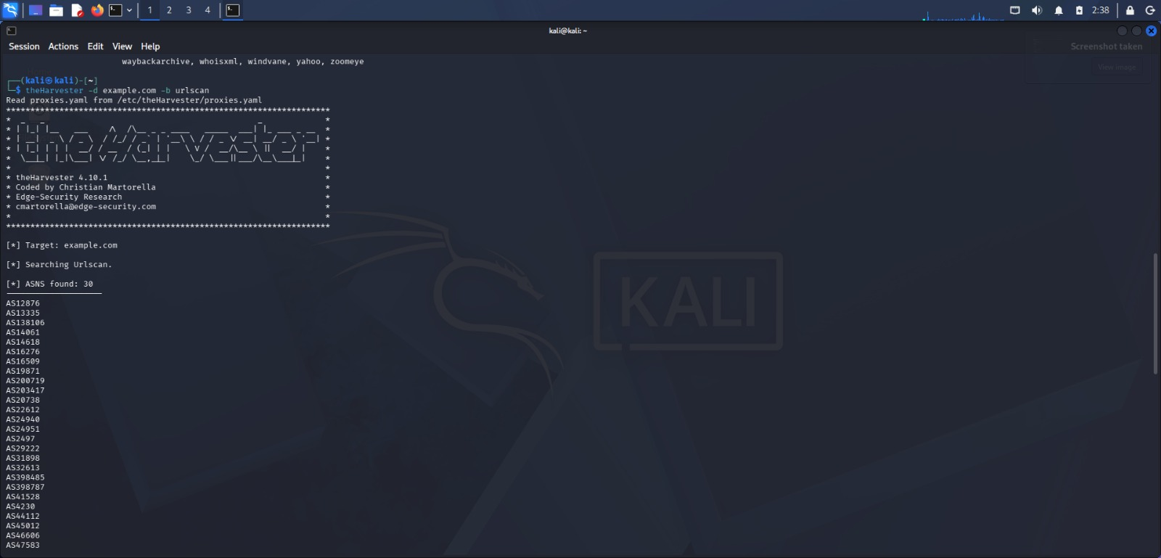
theHarvester run against example.com using the urlscan source — ASNs found
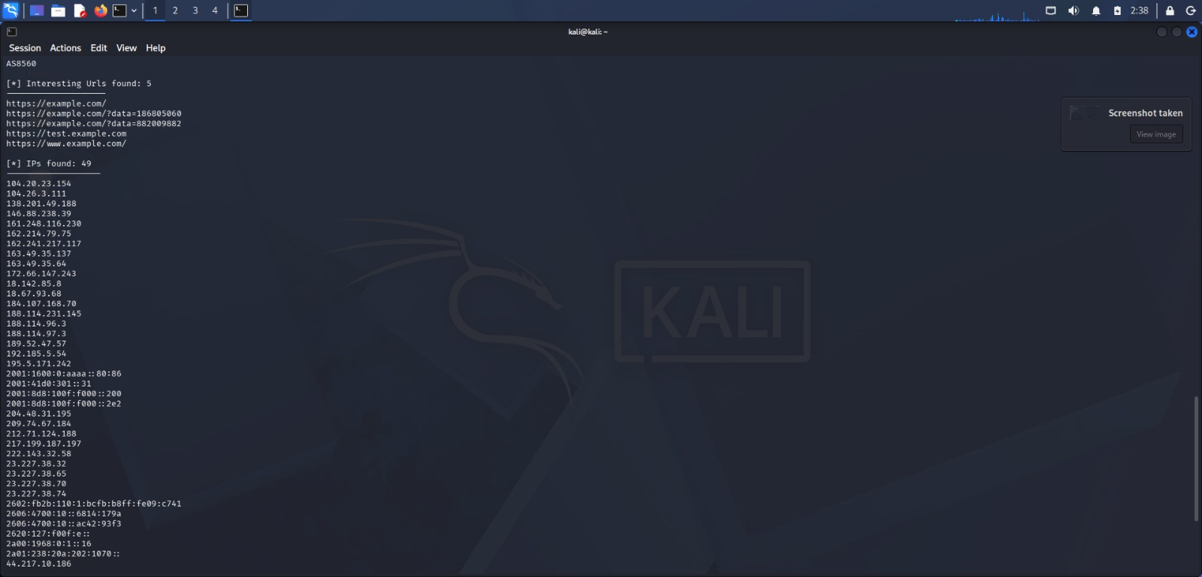
theHarvester results — interesting URLs found and IP addresses discovered
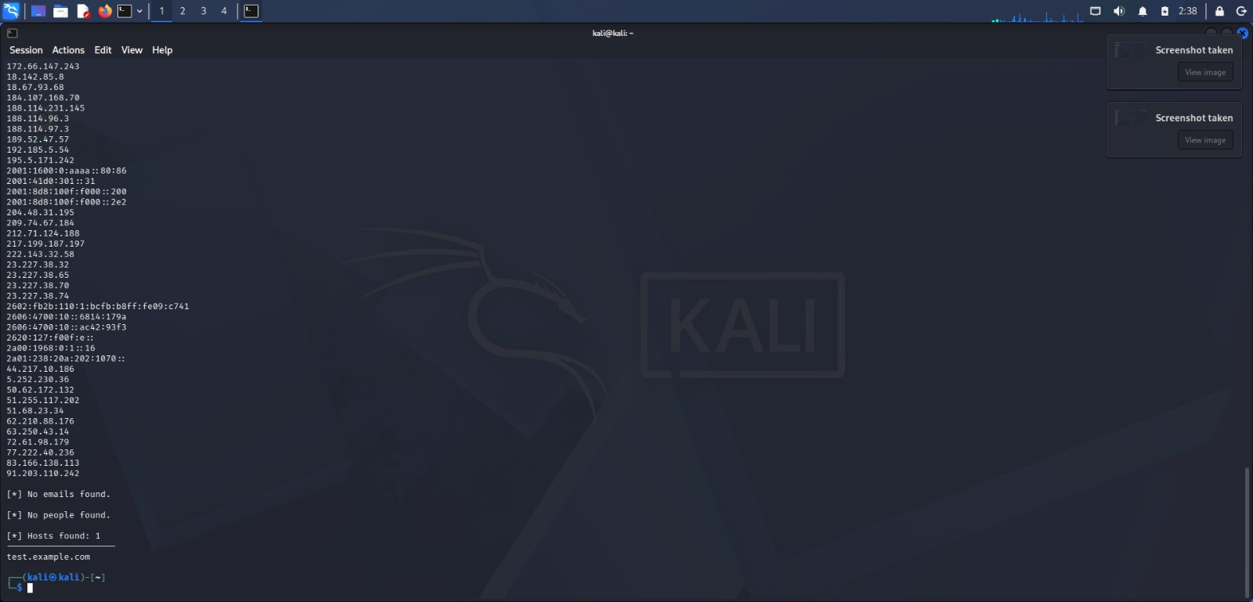
theHarvester summary — no emails or people found; 1 host found (test.example.com)
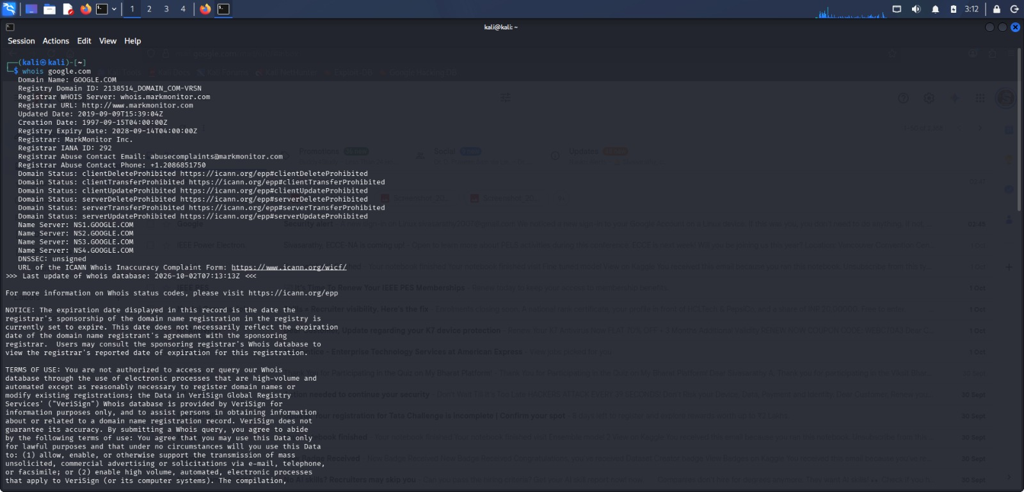
WHOIS query output for google.com — registrar, creation/expiry dates, status and name servers
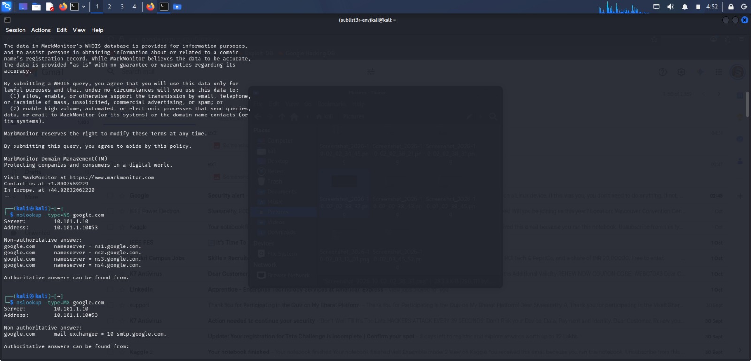
nslookup queries for google.com — NS records (ns1–ns4.google.com) and MX record (smtp.google.com)
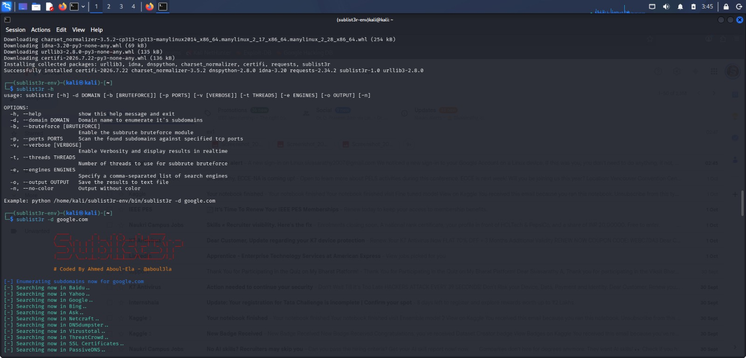
Sublist3r installed in a virtual environment and enumerating subdomains of google.com across search engines
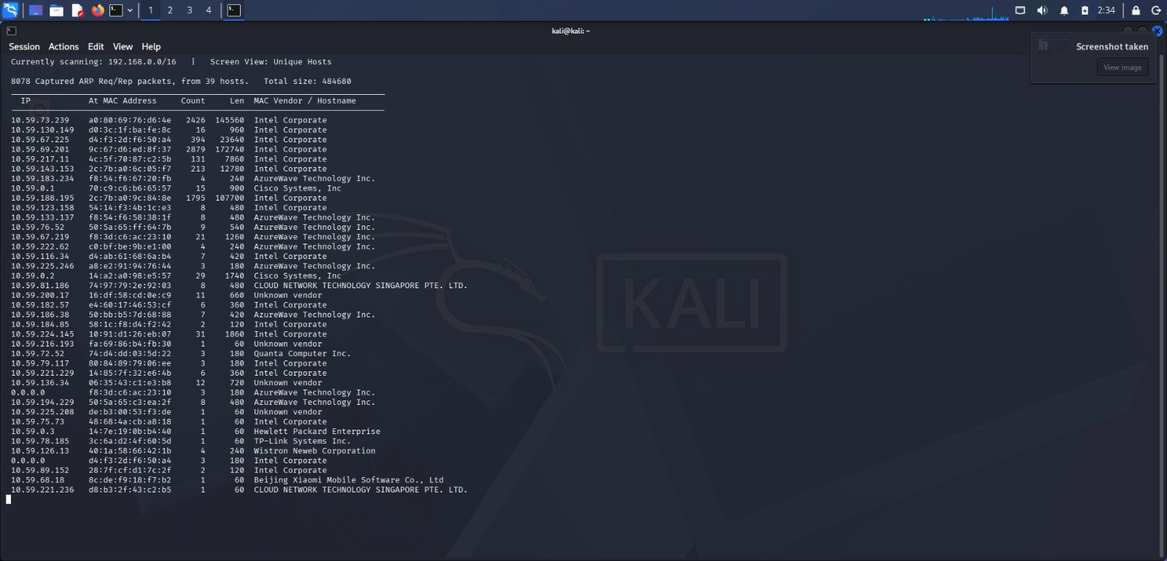
Netdiscover scan results — 8078 ARP packets from 39 hosts with IP, MAC address and vendor
Additional Screenshots: Wireshark Packet Capture
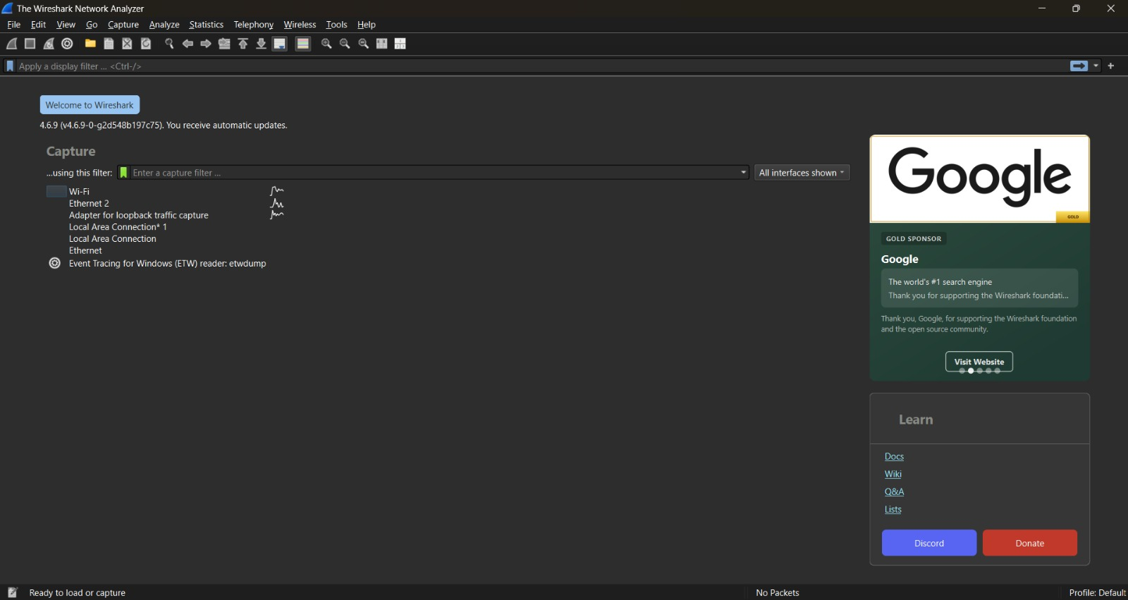
Wireshark 4.6.9 start page listing the available capture interfaces (Wi-Fi, Ethernet, Loopback)
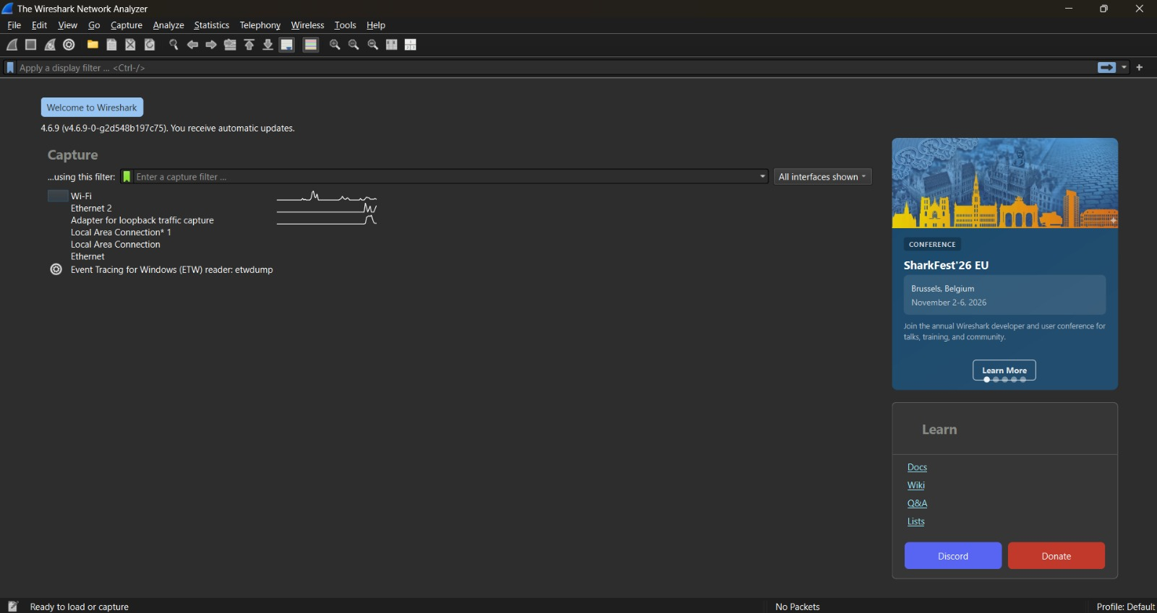
Wireshark start page with live traffic activity shown against the Wi-Fi interface
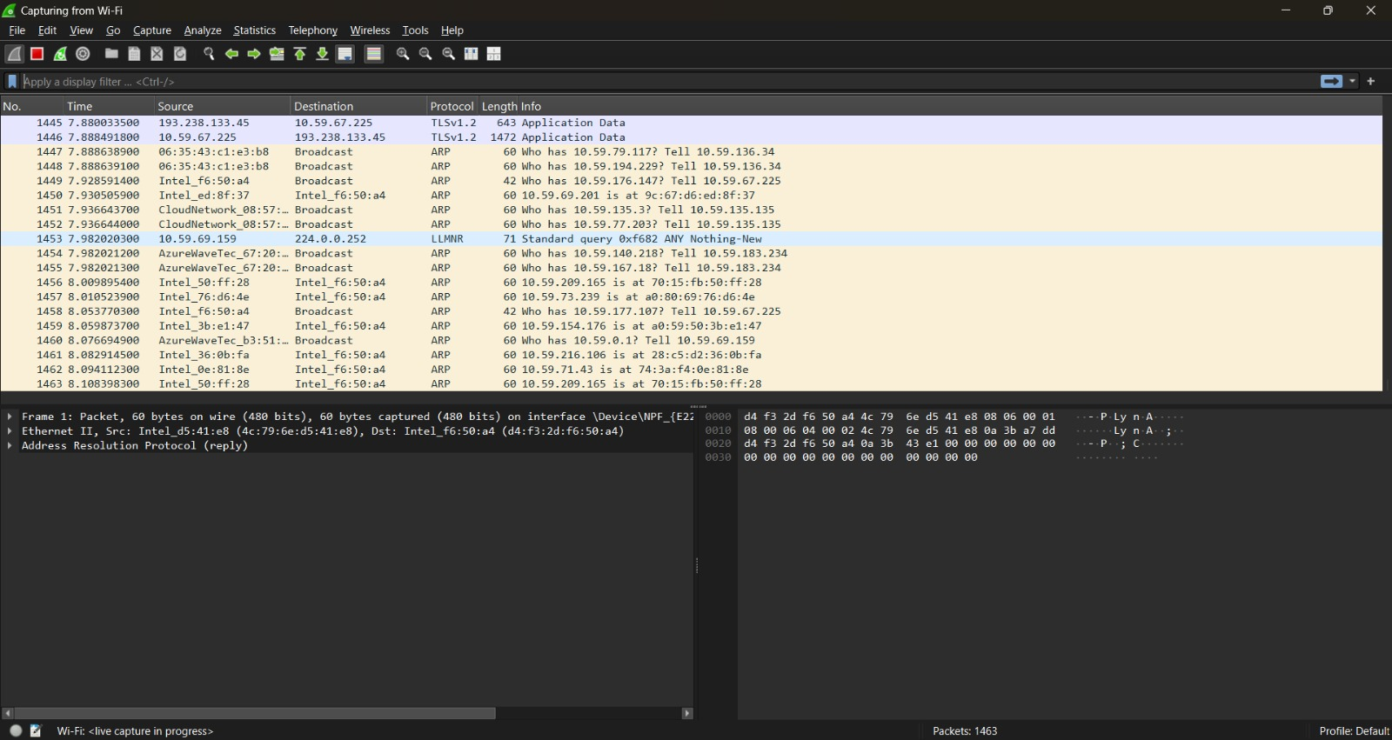
Live packet capture in progress on the Wi-Fi interface (ARP, LLMNR and TLS traffic)
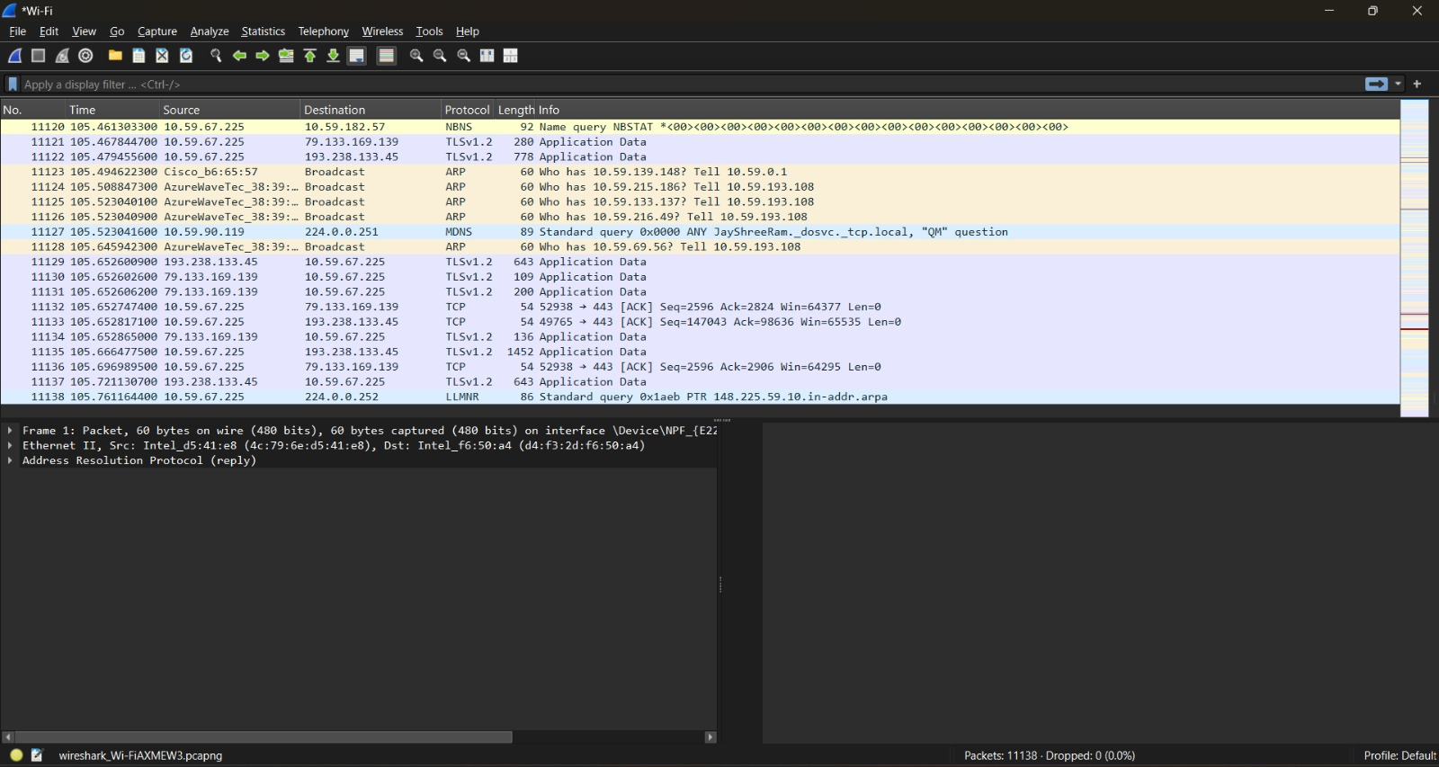
Completed capture of 11,138 packets showing TLS, ARP, NBNS and MDNS traffic
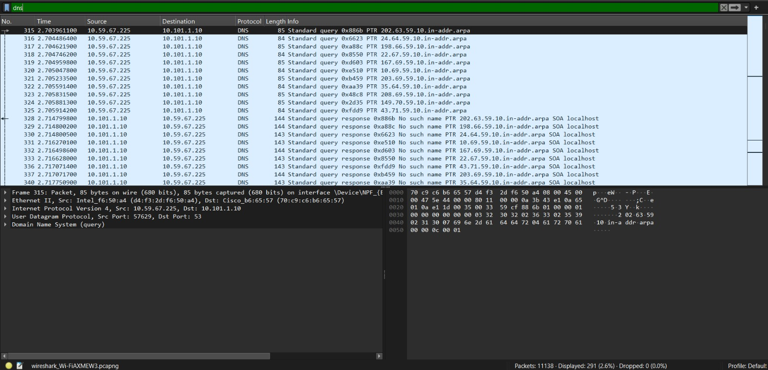
Display filter "dns" applied — 291 DNS PTR queries and responses (2.6% of packets)
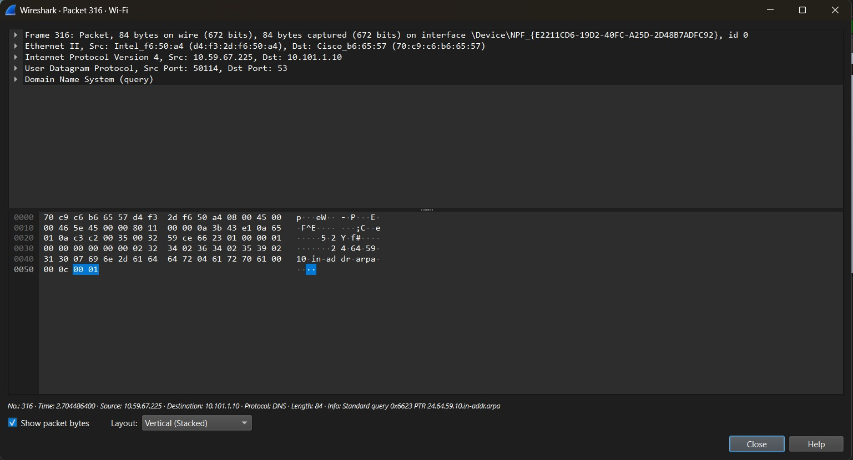
Packet 316 details — DNS standard query (PTR) from 10.59.67.225 to 10.101.1.10 with packet bytes

Result / Learning Outcomes
- Monitored system activities and generated detailed security logs using Sysmon.
- Collected publicly available information about target domains using theHarvester.
- Retrieved domain registration and ownership details using WHOIS.
- Discovered active devices on a local network using Netdiscover.
Ex. No: 3 Date: 29/07/2026

Information Gathering Using Nmap
Objective
To perform information gathering using Nmap, a network scanning tool used for host and service discovery, network mapping, port scanning, OS detection, and service enumeration, against an authorised target (DVWA) within the isolated lab network.
Tools
- Nmap

Methodology
1. Introduce host and service discovery scanning and its role in the vulnerability assessment lifecycle.
2. Install and verify Nmap on Kali Linux.
3. Perform host discovery to identify live systems on the lab network.
4. Perform port scanning to identify open ports on the DVWA target.
5. Perform OS detection and service/version enumeration on discovered open ports.
6. Analyse and document the scan results.

Commands Used
sudo apt install nmap -y
nmap --help
nmap -sn 10.0.2.0/24 # host discovery
nmap 8.8.8.8 # basic port scan
nmap -p 22,80,443,587 <target> # specific ports
nmap -p- <target> # full port scan
sudo nmap -sS 192.168.56.10 # SYN stealth scan
sudo nmap -O 10.49.154.234 # OS detection
nmap -sV 10.49.154.234 # version detection
sudo nmap -sS -sV -O <target> # combined scan
sudo nmap -A <target> # aggressive scan

Sample Output
PORT STATE SERVICE VERSION
22/tcp open ssh OpenSSH 8.2p1 Ubuntu
80/tcp open http Apache httpd 2.4.41
139/tcp open netbios-ssn Samba smbd 4
445/tcp open netbios-ssn Samba smbd 4
8009/tcp open ajp13 Apache Jserv
8080/tcp open http Apache Tomcat 9.0.7

Screenshots
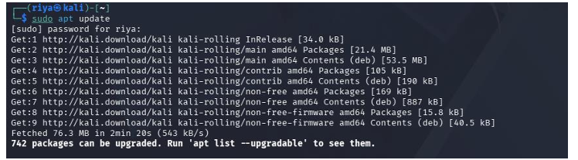
sudo apt update on Kali Linux — package lists refreshed (742 packages upgradable)
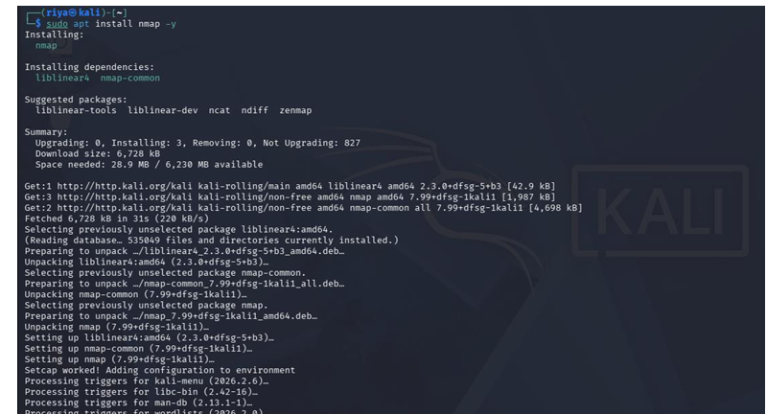
sudo apt install nmap -y — Nmap 7.99 installed along with its dependencies
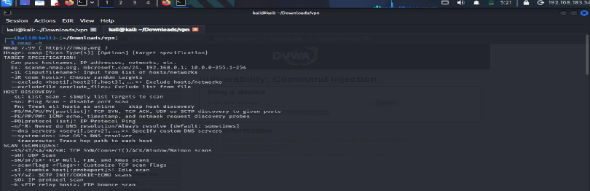
nmap -h — usage banner showing target specification, host discovery and scan techniques
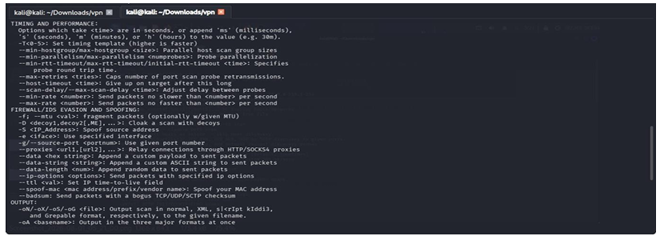
nmap -h (continued) — timing and performance, firewall/IDS evasion and output options
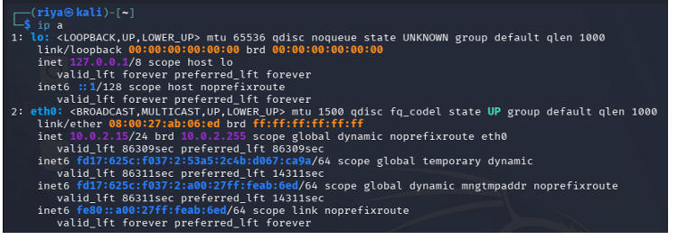
ip a on Kali Linux — eth0 has IP address 10.0.2.15/24 on the lab network
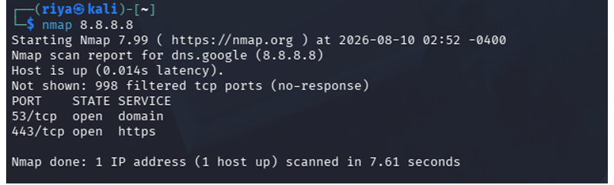
Basic Nmap port scan of 8.8.8.8 — 53/tcp (domain) and 443/tcp (https) open
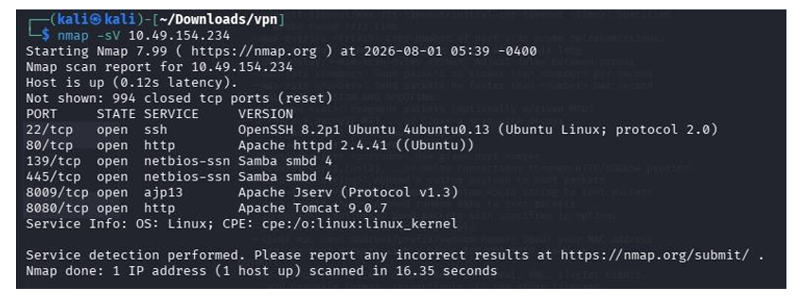
nmap -sV version detection on 10.49.154.234 — SSH, Apache httpd 2.4.41, Samba, Apache Jserv and Tomcat 9.0.7 identified

Result / Learning Outcomes
- Explained the role of host and service discovery in a security assessment.
- Installed and verified Nmap on Kali Linux.
- Performed basic and advanced Nmap scans using common flags.
- Detected the operating system and enumerated running services on the target.
- Analysed and interpreted Nmap scan results to identify potential attack surfaces.
Ex. No: 4 Date: 05/08/2026

Using FOCA / Google Dorking - Metadata Extraction and Target List Expansion
Objective
To perform Open Source Intelligence (OSINT) and passive reconnaissance using FOCA and Google Dorking, gathering metadata, exposed documents, and domain information without directly interacting with the target system.
Tools
- FOCA (Fingerprinting Organizations with Collected Archives)
- Google Search Operators (Google Dorking)

Methodology
1. Install and configure FOCA for metadata extraction and OSINT analysis.
2. Use Google Dorking techniques to discover publicly indexed files and exposed information.
3. Use FOCA to collect metadata from publicly available documents and identify hosts, domains, emails, and software information.
4. Perform passive reconnaissance using public websites and search operators without directly interacting with the target system.
5. Analyse the collected information to understand the organisation's digital footprint and identify potential security exposures.

FOCA Procedure
1. Download FOCA from the official GitHub Releases page and install Microsoft SQL Server Express (required dependency).
2. Launch FOCA.exe and create a new project, entering the target domain name.
3. Click "Search All" to let FOCA query Google, Bing and DuckDuckGo for publicly indexed PDF, DOC, XLS and PPT files.
4. Select the discovered documents and choose "Download All" to save them locally.
5. Right-click a downloaded document and choose "Extract Metadata" to pull author names, software versions and internal file paths.
6. Click "Analyze Metadata" to let FOCA correlate findings across documents, revealing usernames, software and possible network structure.

Google Search Operators
site: restrict results to one domain -> site:owasp.org
filetype: find a specific file type -> filetype:pdf site:owasp.org
intitle: word appears in page title -> intitle:"cheat sheet" site:owasp.org
inurl: word appears in the URL -> inurl:testing-guide site:owasp.org
intext: word appears in page body -> intext:"vulnerability" site:owasp.org
- exclude a term/section -> site:owasp.org -inurl:events
"" exact phrase match -> "threat modeling" site:owasp.org
OR / | match either term -> filetype:pdf OR filetype:pptx
cache: last cached snapshot -> cache:owasp.org

Screenshots
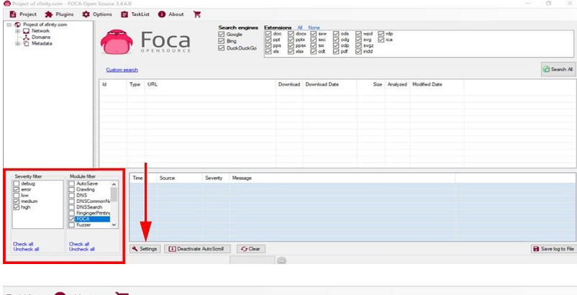
FOCA main window with search engines and file extensions selected; Severity/Module filters and Settings button highlighted
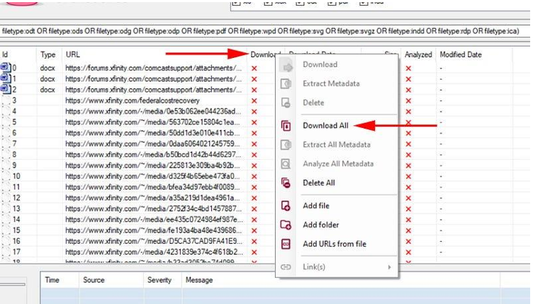
FOCA search results with the right-click menu — “Download All” selected to save the discovered documents
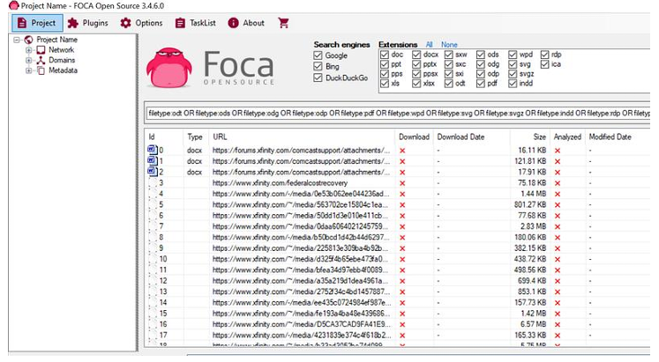
FOCA results table listing the discovered documents with URL, size and download/analysis status

Google Dorking — site: operator restricting results to one domain (gaming laptop site:amazon.com)
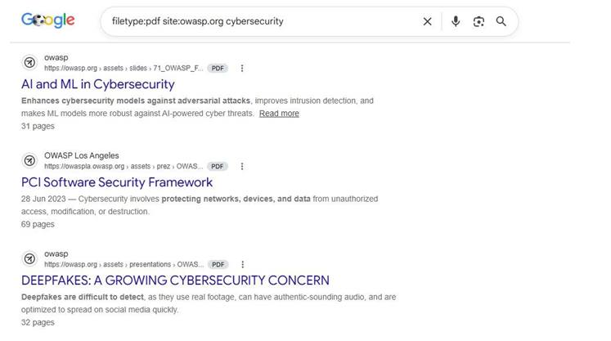
Google Dorking — filetype:pdf site:owasp.org cybersecurity returning PDF documents hosted on owasp.org
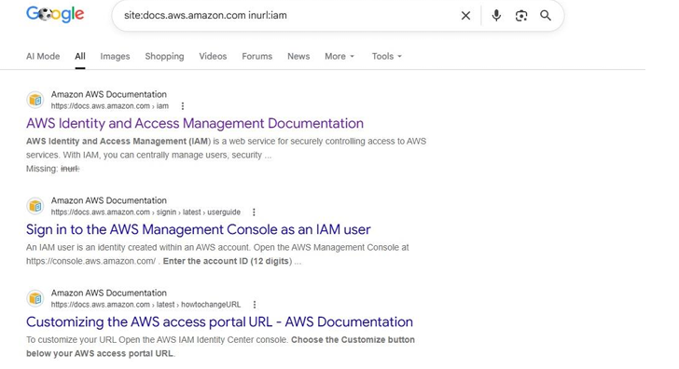
Google Dorking — site:docs.aws.amazon.com inurl:iam returning AWS IAM documentation pages

Result / Learning Outcomes
- Installed and configured the FOCA tool successfully.
- Performed Google Dorking to discover publicly available information.
- Extracted document metadata using FOCA and identified domains, hosts and email addresses.
- Gained practical experience with OSINT and footprinting techniques.
Ex. No: 5 Date: 12/08/2026

Aggregating Information from Public Databases Using Maltego and Shodan
Objective
To perform Open Source Intelligence (OSINT) investigations using Maltego, a visual link-analysis platform, representing information as entities, using transforms to discover related data, and tracing relationships to build a complete picture of a target's digital footprint, further enriched using Shodan.
Tools
- Maltego Community Edition (CE)
- Shodan

Methodology
1. Introduce the concept of OSINT and how it applies to visual link-analysis tools.
2. Install and configure Maltego Community Edition for entity-based investigation.
3. Use Maltego transforms to discover DNS names, email addresses, and IP addresses related to a target domain.
4. Trace relationships between discovered entities to identify significant connections (e.g. shared infrastructure).
5. Enrich findings using Shodan to cross-verify and expand the investigation.
6. Analyse the collected information to compile a documented OSINT assessment.

Core Concepts
- Entity - a single piece of data, such as a Domain, Email Address, Person, or IP Address.
- Transform - a query that takes one entity and discovers new, related entities.
- Graph - the growing visual map of entities and the links between them.

Procedure
1. Register a Maltego Community Edition account and install Maltego Graph (Desktop).
2. Log in with the Maltego ID, select default Utilities data sources and finish setup.
3. Go to File > New Graph and drag a Domain entity onto the canvas.
4. Double-click the entity and set it to the authorised training domain (e.g. ssn.edu.in).
5. Right-click the Domain entity > Run Transform > "To DNS Name [DNS]" to discover subdomains.
6. Right-click the Domain entity > Run Transform > "To Email Address [SEC/PGP]" to discover related email addresses.
7. Select a discovered IP Address entity, then search it on shodan.io to view publicly observed open ports and service banners.

Screenshots
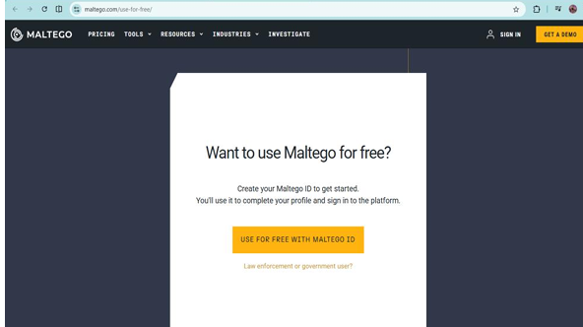
Maltego “Use for free” page — creating a Maltego ID to access the Community Edition
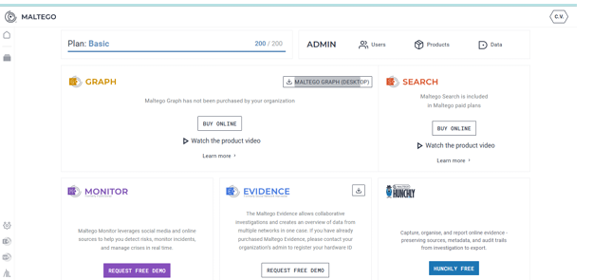
Maltego account portal showing the Basic plan and the available products (Graph, Search, Monitor, Evidence, Hunchly)
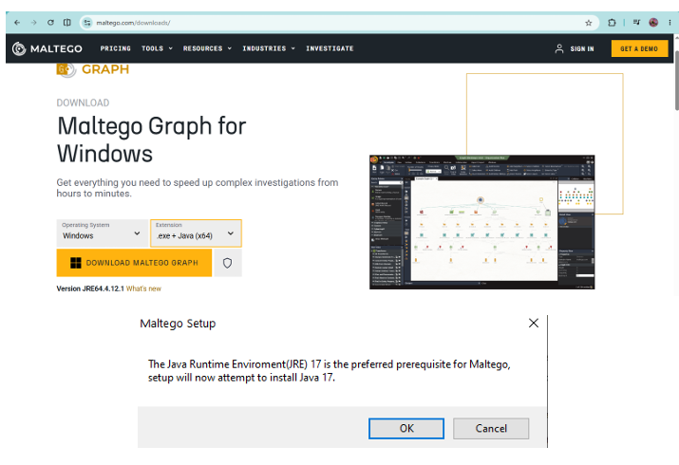
Maltego Graph for Windows download page (.exe + Java x64) and the setup prompt installing Java 17 (JRE)
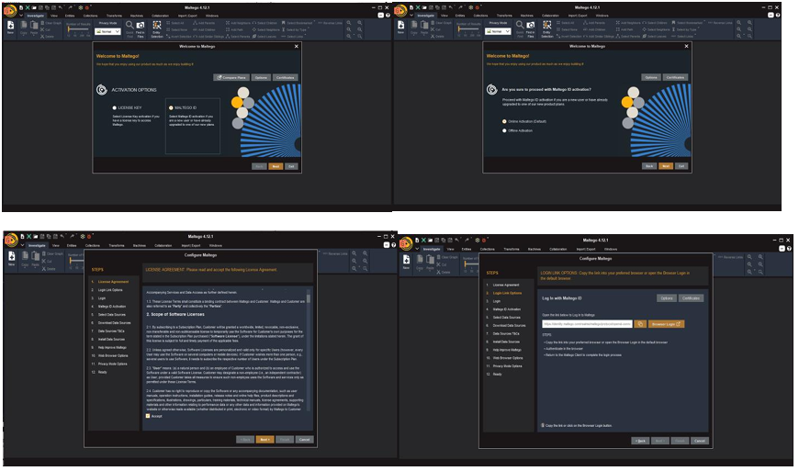
Maltego 4.12.1 first-run configuration wizard — activation options, Maltego ID activation, license agreement and browser login
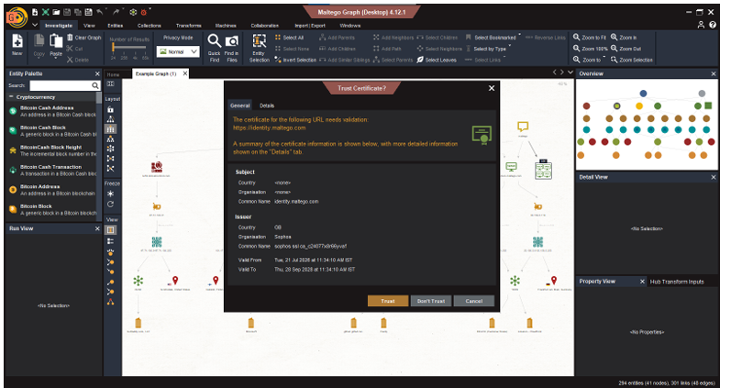
Maltego Graph (Desktop) 4.12.1 main window with the Trust Certificate prompt for identity.maltego.com after login
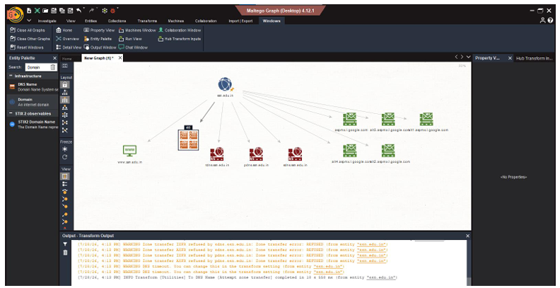
Maltego graph for ssn.edu.in — domain entity linked to its website, name servers and Google MX hosts, with the Transform Output window
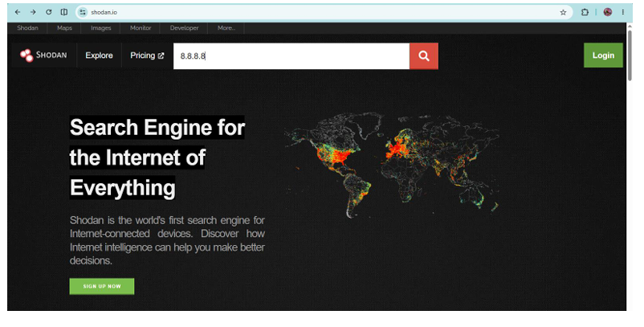
Shodan home page with the IP address 8.8.8.8 entered in the search bar
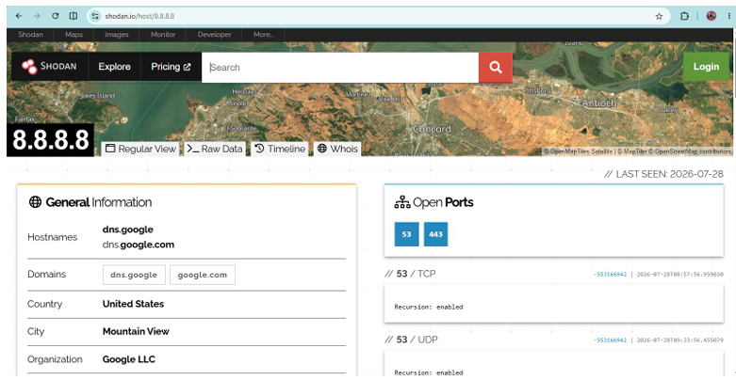
Shodan host page for 8.8.8.8 — hostnames, organisation (Google LLC) and open ports 53 and 443

Result / Learning Outcomes
- Explained the core principles of OSINT and its role in ethical hacking.
- Built an entity graph using domain, DNS, email, and IP transforms in Maltego.
- Traced relationships between entities to identify significant findings.
- Used Shodan to enrich and verify OSINT findings from the Maltego graph.
Ex. No: 6 Date: 19/08/2026

Information Gathering Using Robtex
Objective
To use Robtex, a free web-based network and DNS intelligence tool, to perform passive footprinting of a target domain - mapping DNS records, discovering related domains sharing infrastructure, and identifying network/ASN ownership information, entirely through Robtex's public web interface.
Tools
- Robtex (robtex.com)

Methodology
1. Introduce Robtex as a passive, browser-based DNS and network intelligence tool.
2. Perform a domain lookup to review DNS records (A, MX, NS, TXT).
3. Use Robtex's graph view to visualise relationships between a domain, its IP addresses, and shared-hosting neighbours.
4. Perform an IP address lookup to identify the network range and ASN (Autonomous System Number) it belongs to.
5. Cross-reference Robtex findings with tools used in earlier experiments (WHOIS, crt.sh, DNSdumpster).

Procedure
1. Navigate to https://www.robtex.com in a standard web browser; no account or installation is required.
2. Enter the authorised training domain into the Robtex search bar and press Enter.
3. Review the Domain Reputation panel and the summary of resolved IP address(es) and hosting details.
4. Scroll through the Subdomains, Same first word, and DNS History panels to understand the domain's footprint.
5. Open the DNS Trace view to inspect the Delegation Chain, Authoritative Response, DNSSEC Status and Records.

DNS Record Types Interpreted
- A record - maps the domain to an IPv4 address.
- MX record - identifies the mail server(s) responsible for the domain's email.
- NS record - identifies the domain's authoritative name servers.
- TXT record - often contains SPF/DKIM policies or domain verification strings.

Screenshots
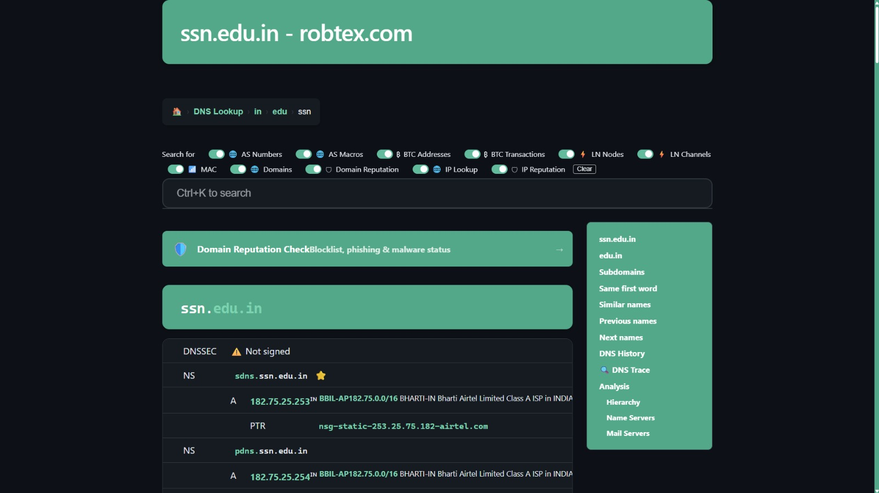
Robtex domain lookup for ssn.edu.in showing NS and A records with hosting details
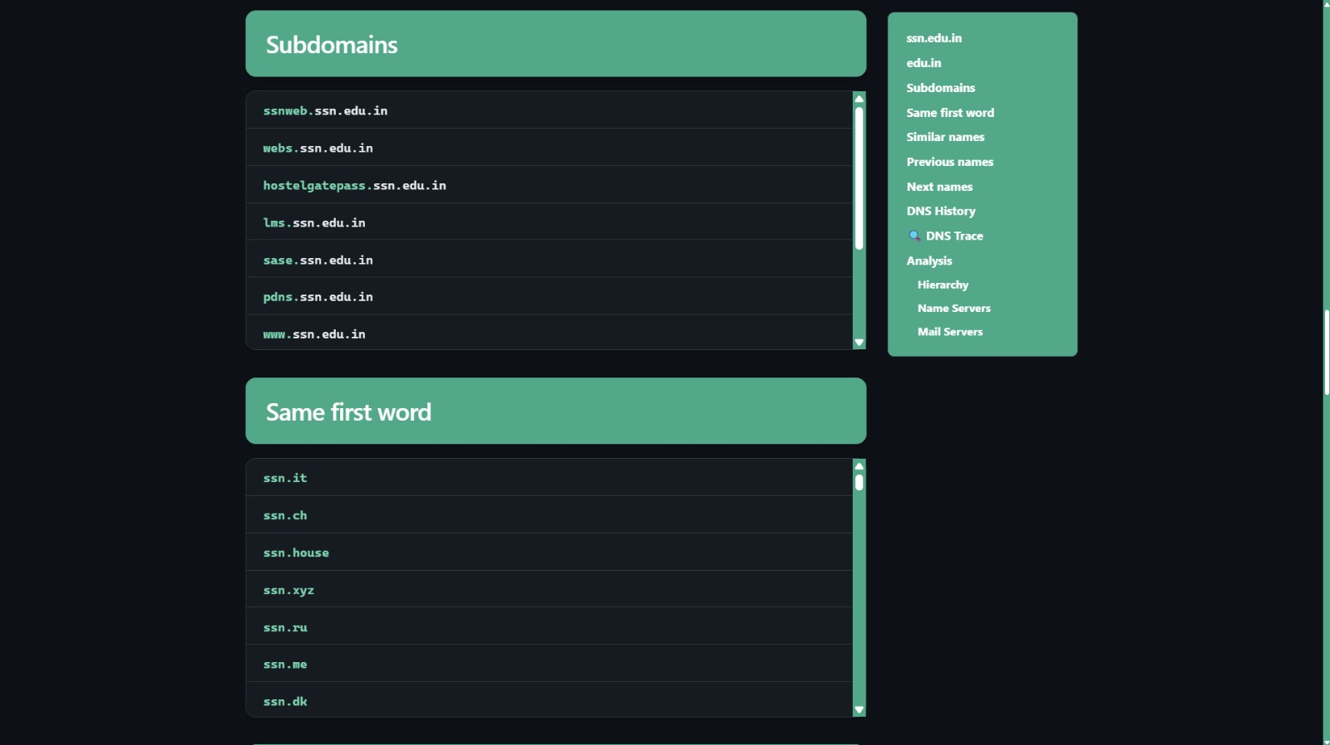
Robtex Subdomains and Same first word panels for ssn.edu.in
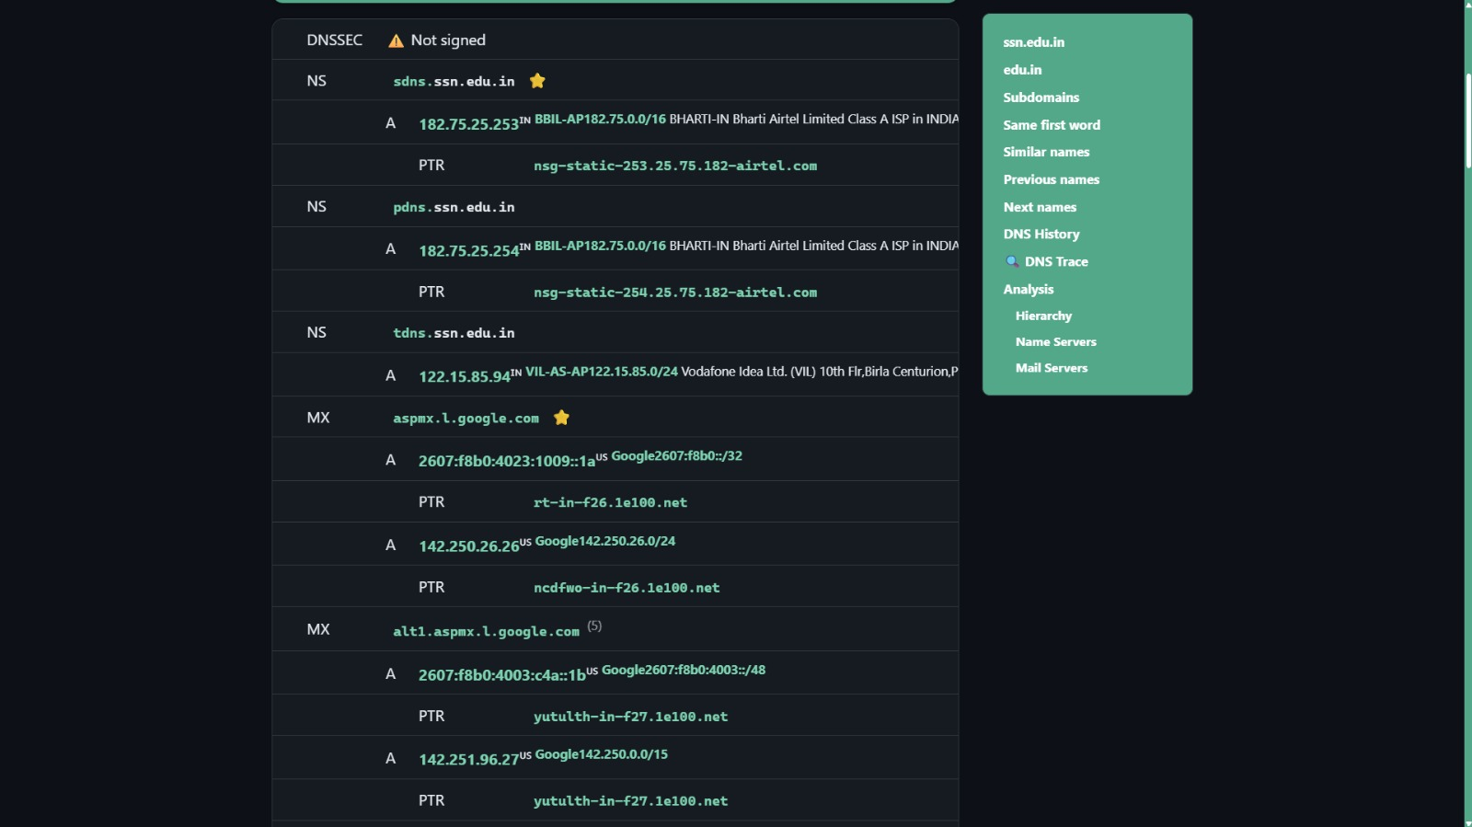
Robtex DNS records detail — NS and MX records with resolved IPs
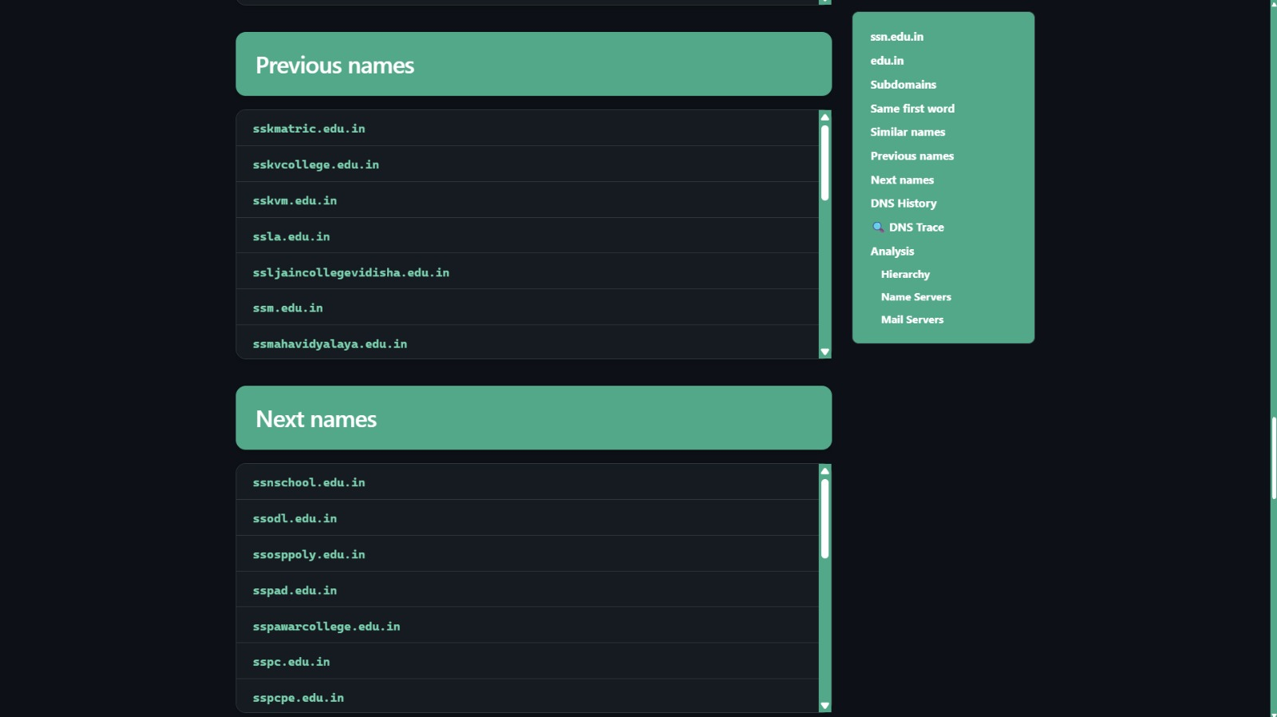
Robtex Previous names and Next names panels
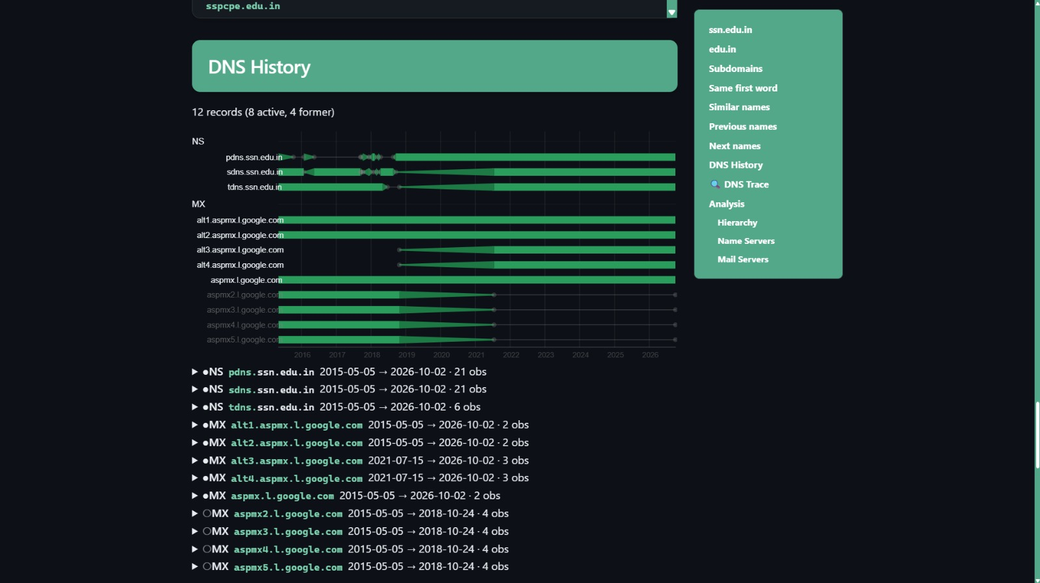
Robtex DNS History graph showing NS and MX record changes over time
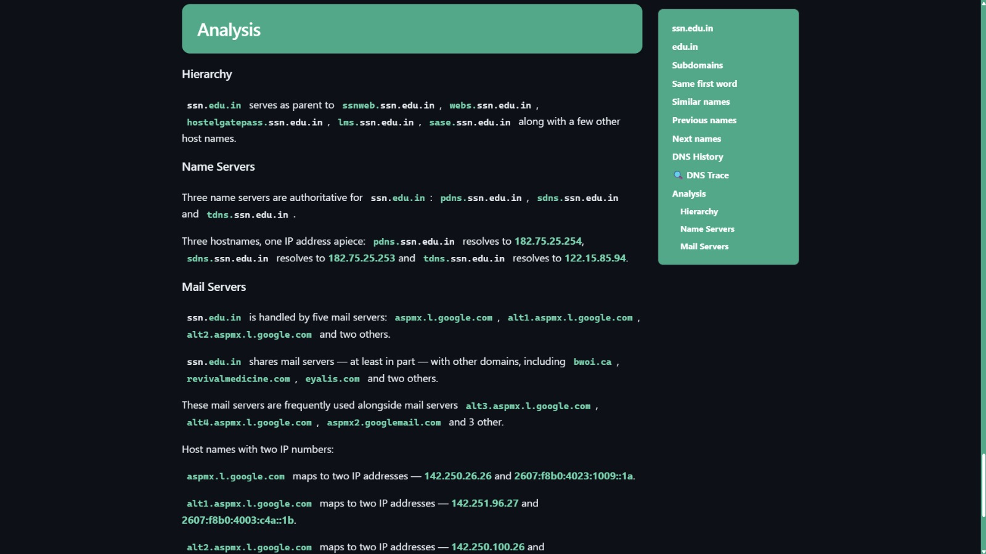
Robtex Analysis panel — Hierarchy, Name Servers and Mail Servers summary
Result / Learning Outcomes
- Explained what Robtex is and how it fits alongside other passive footprinting tools.
- Performed a domain lookup and interpreted the returned DNS records.
- Used Robtex's graph view to identify shared-hosting relationships.
- Cross-referenced Robtex data against other OSINT sources for verification.
Ex. No: 7 Date: 26/08/2026

Vulnerability Assessment Using Nessus
Objective
To perform vulnerability assessment using Nessus, an automated vulnerability scanning tool. Nessus Essentials was installed and activated, an authorised target was scanned for known vulnerabilities, and the identified findings were assessed by severity and associated CVE references.
Tools
- Nessus Essentials (Tenable)

Methodology
1. Introduce vulnerability assessment concepts and how Nessus fits into the overall security assessment lifecycle.
2. Install and activate Nessus Essentials on Kali Linux / Windows.
3. Configure and run a vulnerability scan against an authorised target (DVWA or Metasploitable).
4. Review the generated scan report and interpret findings by severity.
5. Review CVE references associated with identified vulnerabilities.
6. Compare Nessus findings against the open-source counterpart, OpenVAS, at a conceptual level.

Installation & Setup
1. Download the Nessus installer from tenable.com/downloads/nessus and install it.
2. Request a free activation code from tenable.com/products/nessus/.
3. Open https://localhost:8834, accept the self-signed certificate, and select Nessus Essentials.
4. Enter the activation code, create an administrator account and wait for the plugin feed to download.

Running the Scan
1. From My Scans, click New Scan and choose the Basic Network Scan template.
2. Name the scan and enter the authorised target IP address (e.g. the Metasploitable VM) in the Targets field.
3. Click Save, then click the Play icon to launch the scan and monitor progress until completion.

Severity Ratings
- Critical: immediate, severe risk; allows complete system compromise, remote code execution, or full administrative access.
- High: significant risk; allows unauthorized data access, privilege escalation, or full service disruption.
- Medium: moderate risk; typically requires conditional access or specific configuration states to exploit.
- Low: minor risk; includes misconfigurations, protocol weaknesses, or informational disclosures.
- Info: non-vulnerable findings; operational or contextual system detail.

Sample Finding
A Critical finding, "PHP 5.3.x < 5.3.15 Multiple Vulnerabilities" (Plugin #60085), was identified on the Metasploitable target, referencing CVE-2012-2688 and CVE-2012-3365. Cross-referencing CVE-2012-3365 on cve.org showed it allows the open_basedir protection mechanism to be bypassed via the SQLite functionality in PHP.
Screenshots
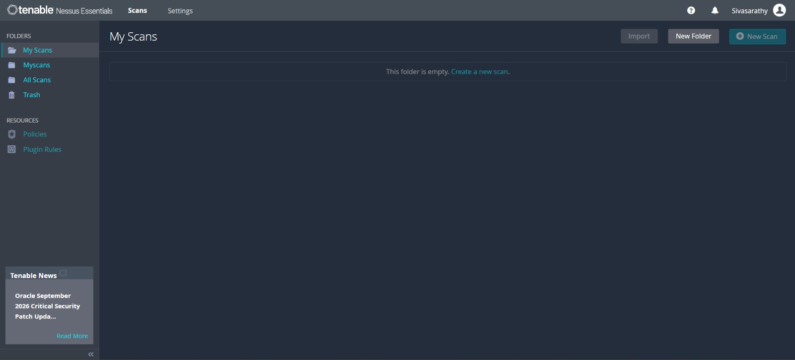
Nessus Essentials — My Scans (empty, logged in as Sivasarathy)
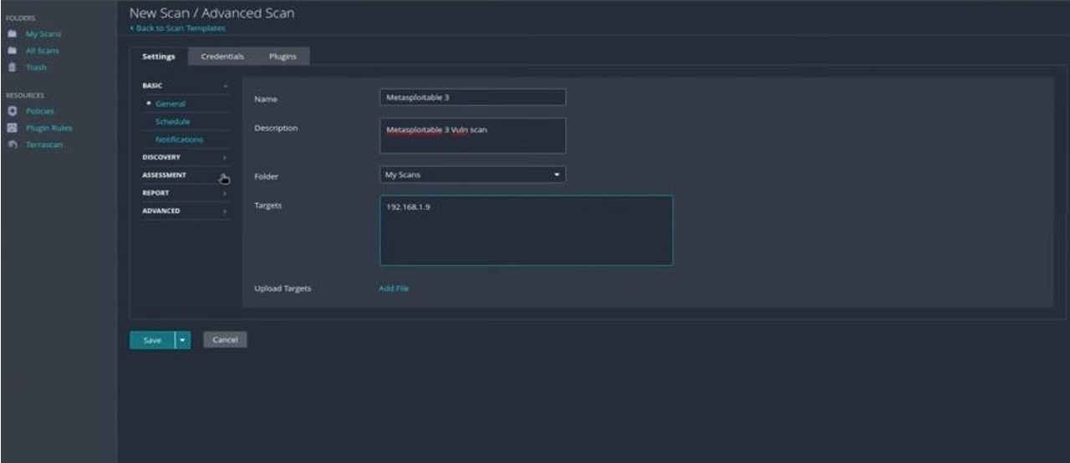
New Scan – Advanced Scan configuration for Metasploitable 3, target 192.168.1.9
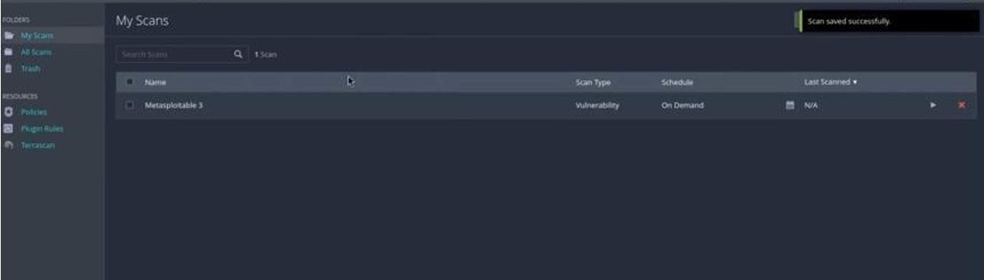
Scan saved successfully — Metasploitable 3 listed under My Scans
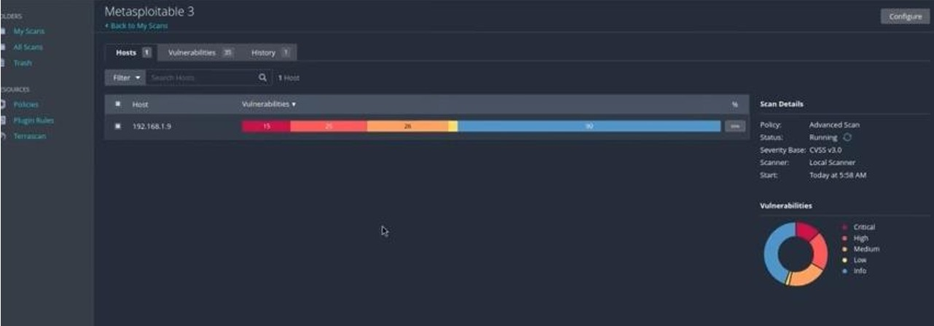
Completed scan results for Metasploitable 3 showing severity distribution (Critical/High/Medium/Low/Info)
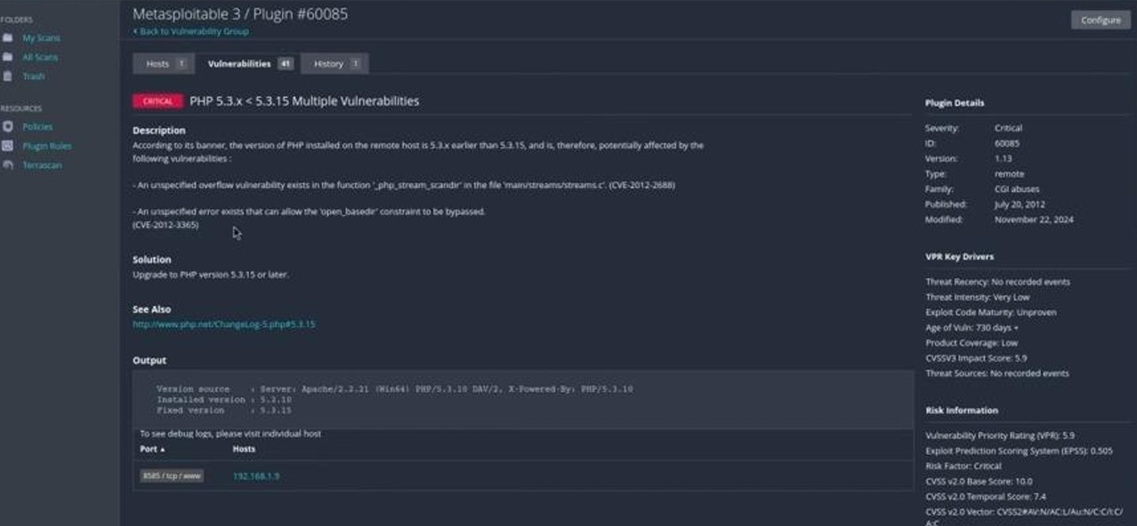
Vulnerability finding detail: PHP 5.3.x < 5.3.15 Multiple Vulnerabilities (Plugin #60085, CVE-2012-2688, CVE-2012-3365)
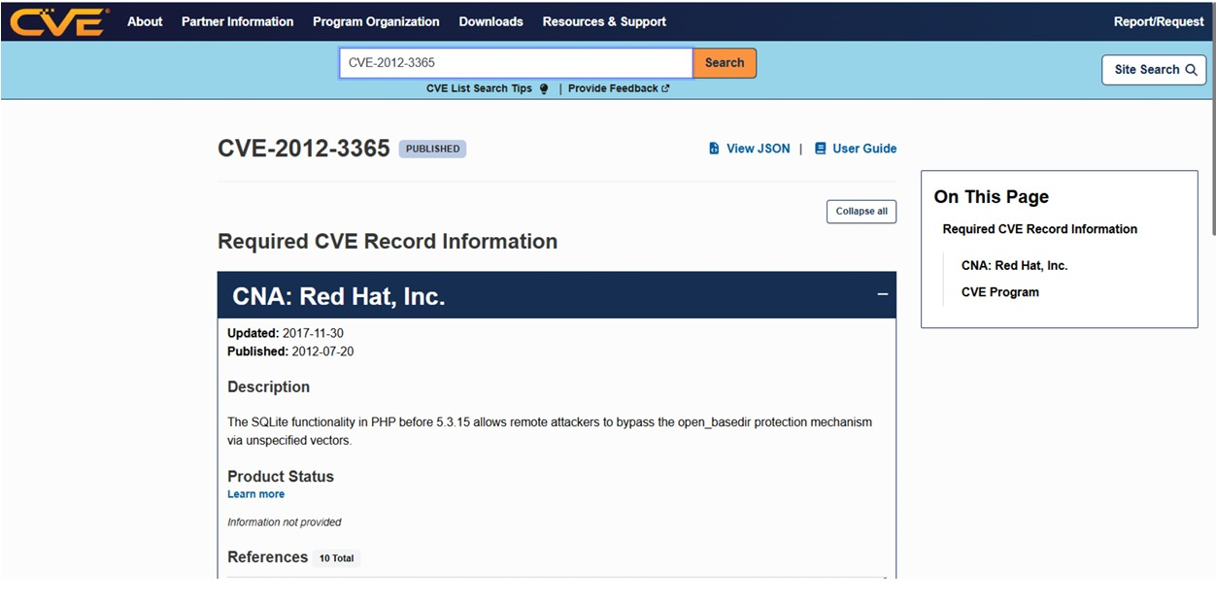
Cross-referencing CVE-2012-3365 on cve.org — SQLite open_basedir bypass description
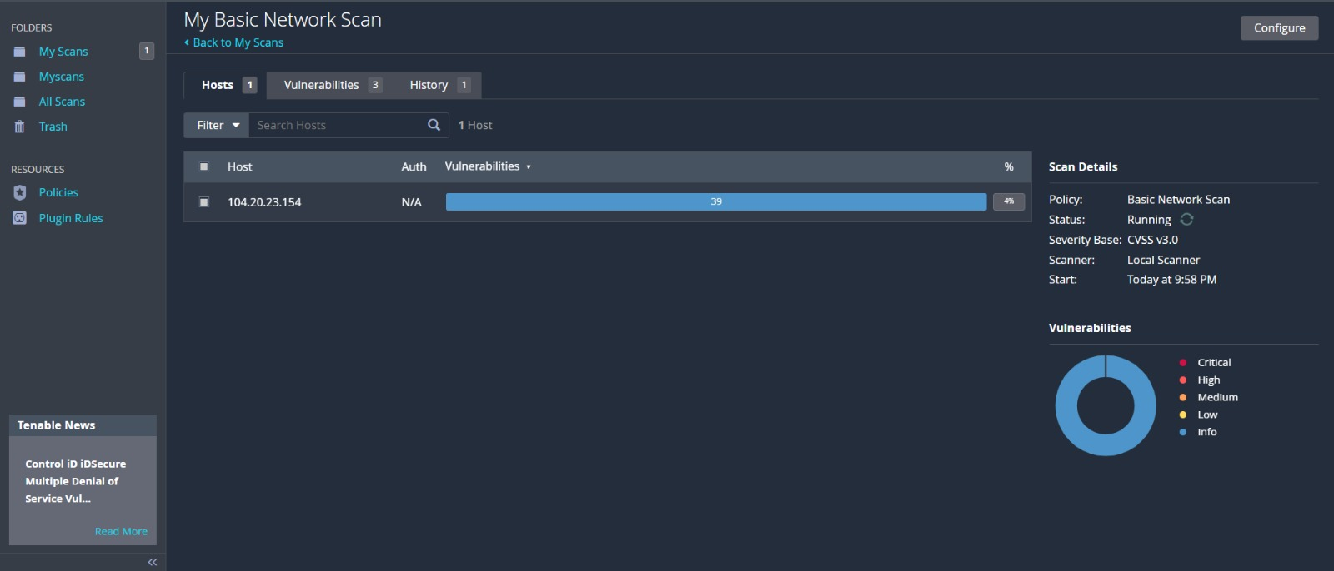
Additional scan example — Basic Network Scan against 104.20.23.154 showing 39 vulnerabilities found
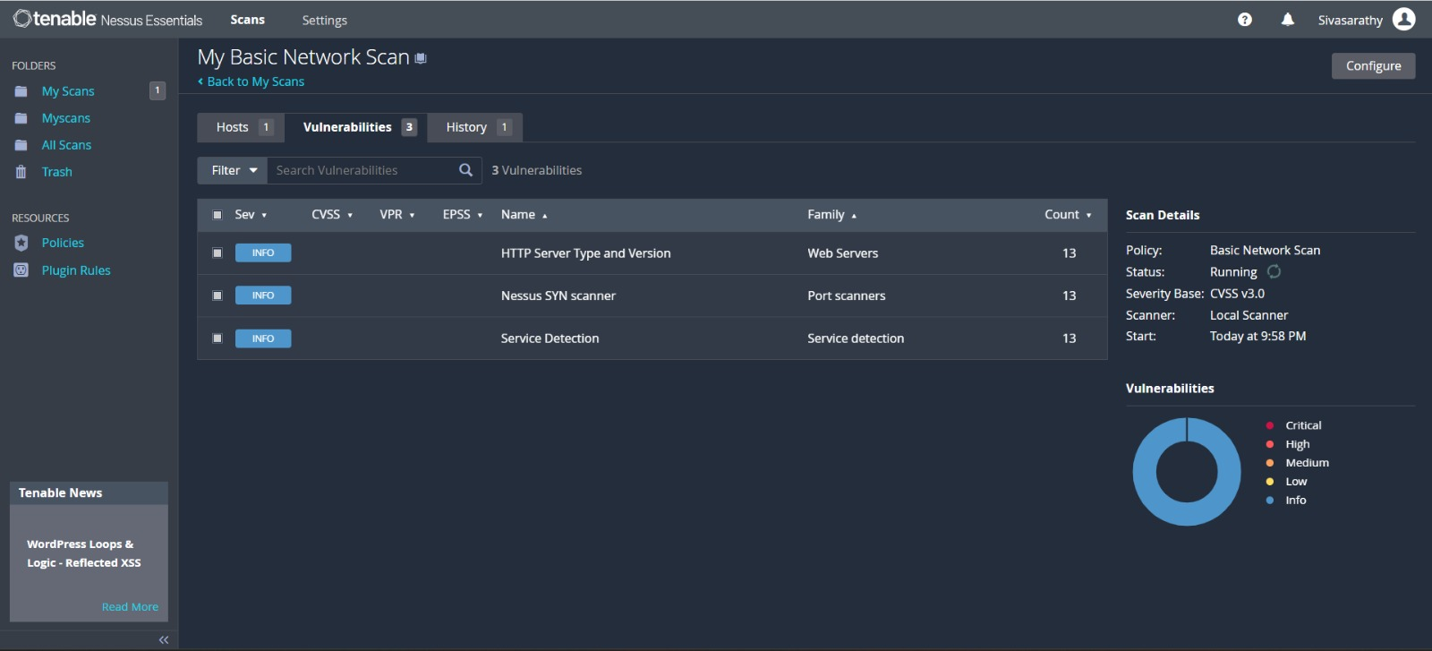
Basic Network Scan — Vulnerabilities tab listing HTTP Server Type and Version, Nessus SYN scanner and Service Detection (Info)
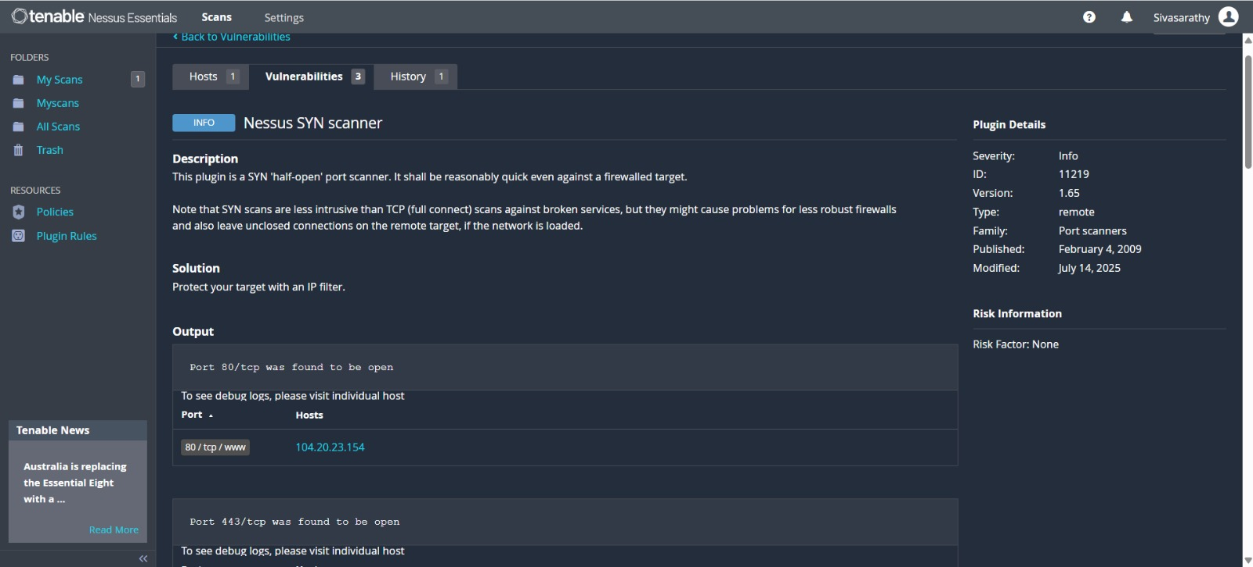
Nessus SYN scanner (Plugin #11219) output — ports 80/tcp and 443/tcp found open on 104.20.23.154
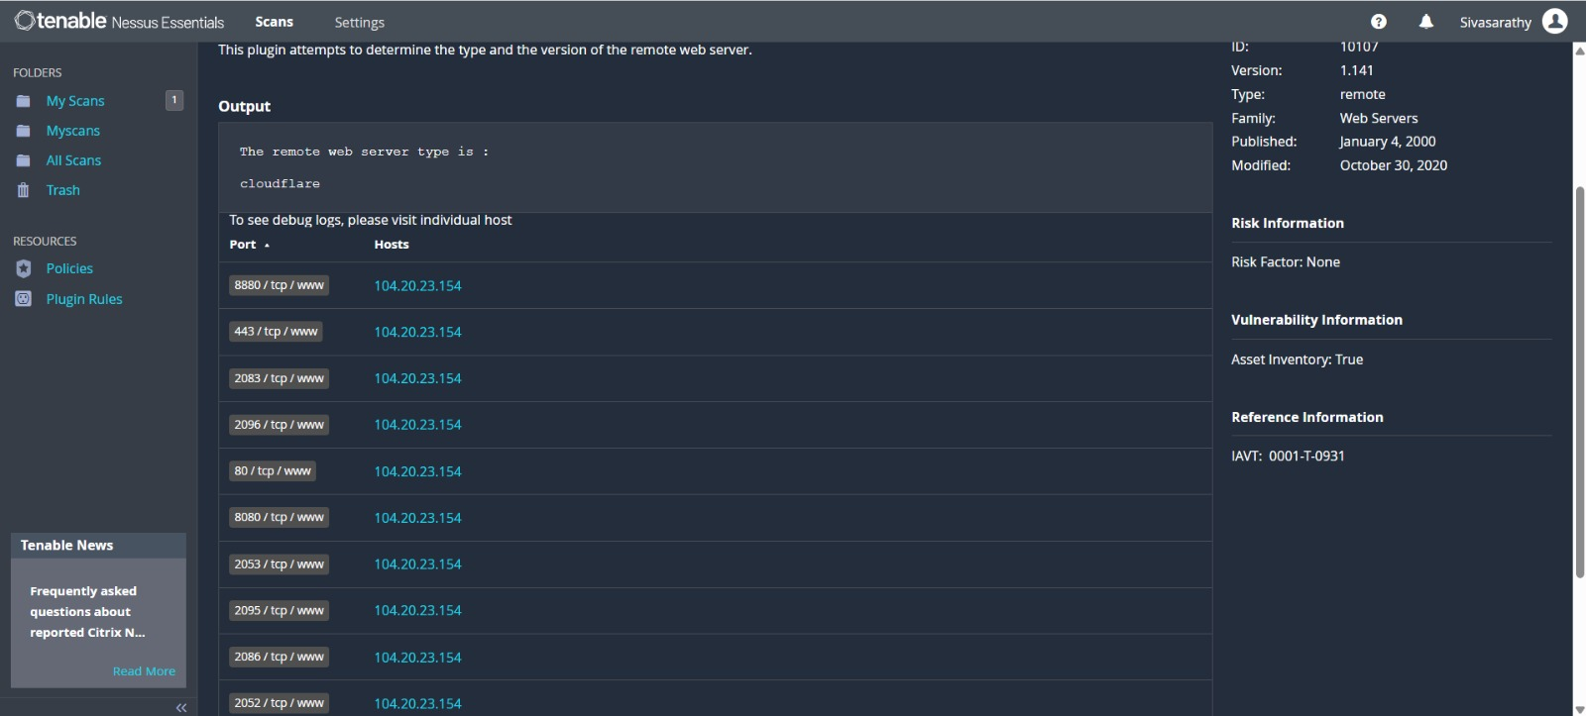
HTTP Server Type and Version (Plugin #10107) — remote web server identified as cloudflare on ports 80, 443, 2052, 2053, 2083, 2086, 2095, 2096, 8080 and 8880
Result / Learning Outcomes
- Explained the role of vulnerability assessment in an ethical hacking engagement.
- Installed, activated, and accessed the Nessus web interface.
- Scanned an authorised target and generated a vulnerability assessment report.
- Identified vulnerabilities and classified them by severity.
- Reviewed CVE references and assessed the real-world risk of reported findings.
Ex. No: 8 Date: 02/09/2026

Automate Attack Discovery and Exploit Matching Using Armitage
Objective
To install and use Armitage, a graphical cyber-attack management front-end for the Metasploit Framework, in an isolated lab network - installing Armitage and its dependencies, connecting it to the Metasploit RPC service, organising targets using workspaces, discovering hosts, identifying applicable exploits, and carrying out controlled exploitation and post-exploitation using Meterpreter.
Tools
- Armitage
- Metasploit Framework
- PostgreSQL

Methodology / Procedure
1. Review Armitage and its role as a Java GUI client that talks to Metasploit's RPC daemon (msfrpcd).
2. Install Armitage and the required Java, Metasploit and PostgreSQL components: sudo apt update && sudo apt install armitage.
3. Start PostgreSQL and initialise the Metasploit database: sudo service postgresql start, then sudo msfdb init.
4. Launch Armitage with root privileges (sudo armitage), connect to 127.0.0.1:55553 and allow it to start msfrpcd.
5. Create a new workspace (Workspaces > Manage), e.g. "lab-week9-armitage", to keep hosts and sessions separate.
6. Discover hosts using Hosts > Nmap Scan > Quick Scan (OS detect) on the authorised lab network range.
7. Select the discovered hosts and run Attacks > Find Attacks so Armitage compares recorded services against its exploit database.
8. Right-click a target, choose Attack, review RHOSTS/RPORT/LHOST/LPORT options, and click Launch to run the suggested exploit.
9. Once a session opens (host turns red with a lightning-bolt icon), right-click and choose Meterpreter > Interact to run commands such as sysinfo, getuid and ps.
10. Use Explore > Browse Files, Explore > Screenshot, Access > Escalate Privileges and Access > Dump Hashes for controlled post-exploitation on the authorised target.

Key Commands
$ sudo apt update && sudo apt install armitage
$ sudo service postgresql start
$ sudo msfdb init
$ sudo armitage
meterpreter > sysinfo
meterpreter > getuid
meterpreter > screenshot
meterpreter > hashdump

Observations
Armitage successfully connected to the Metasploit RPC server and populated the Targets panel with the lab hosts (Metasploitable2, Windows 7/Server VMs). Running Find Attacks tagged each host with an Attack submenu of matching exploit modules such as exploit/unix/ftp/vsftpd_234_backdoor and exploit/multi/samba/usermap_script. Launching the usermap_script exploit against the Metasploitable target produced an active Meterpreter session, from which sysinfo and hashdump were executed to confirm successful, controlled exploitation on the authorised lab target.
Caution
Armitage and Metasploit were used strictly within the isolated Host-only lab network and only against Metasploitable/designated training targets that the student owns or is explicitly authorised to test.
Screenshots
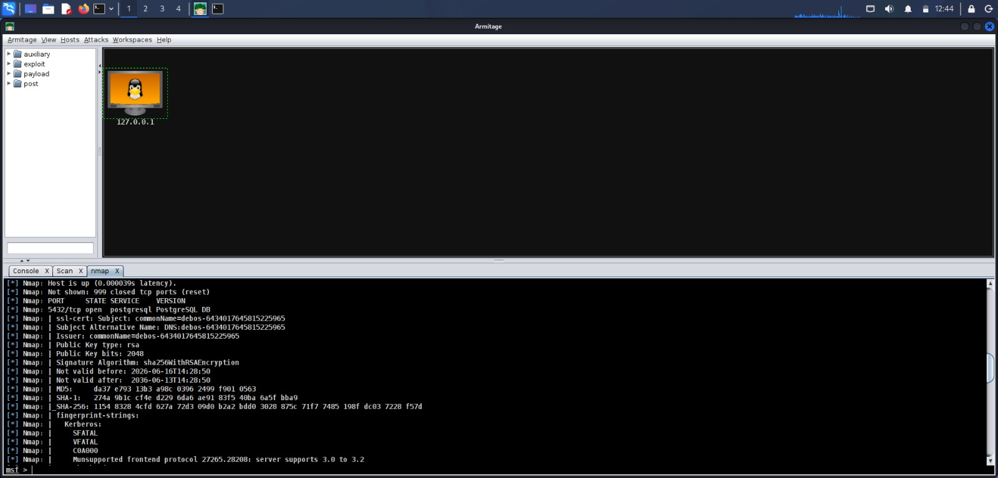
Armitage with target host 127.0.0.1 in the Targets panel and Nmap service-scan output (5432/tcp PostgreSQL)
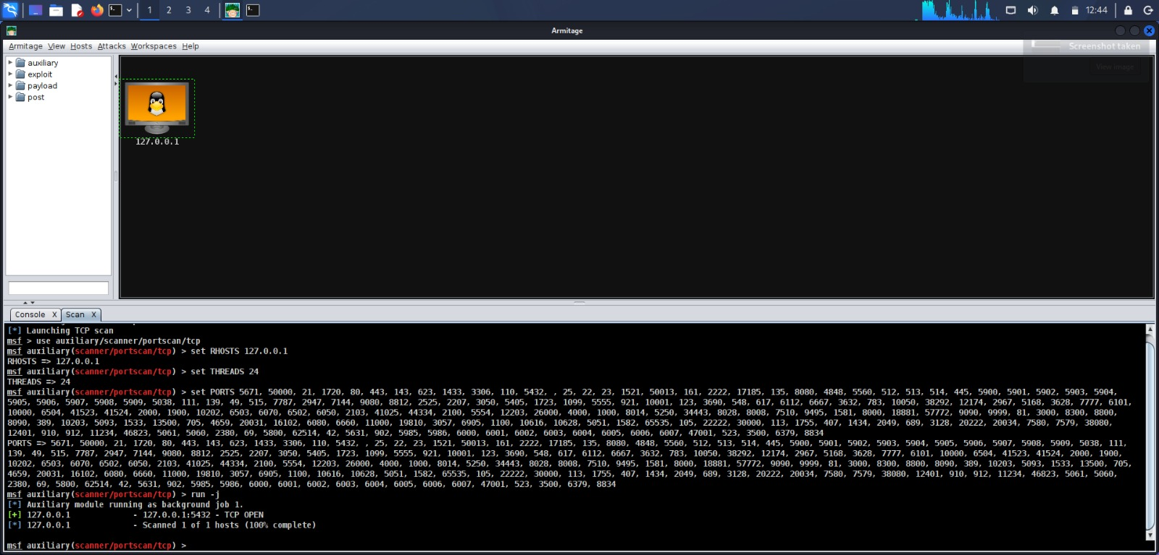
Scan tab — auxiliary/scanner/portscan/tcp run against 127.0.0.1 showing 5432/tcp OPEN
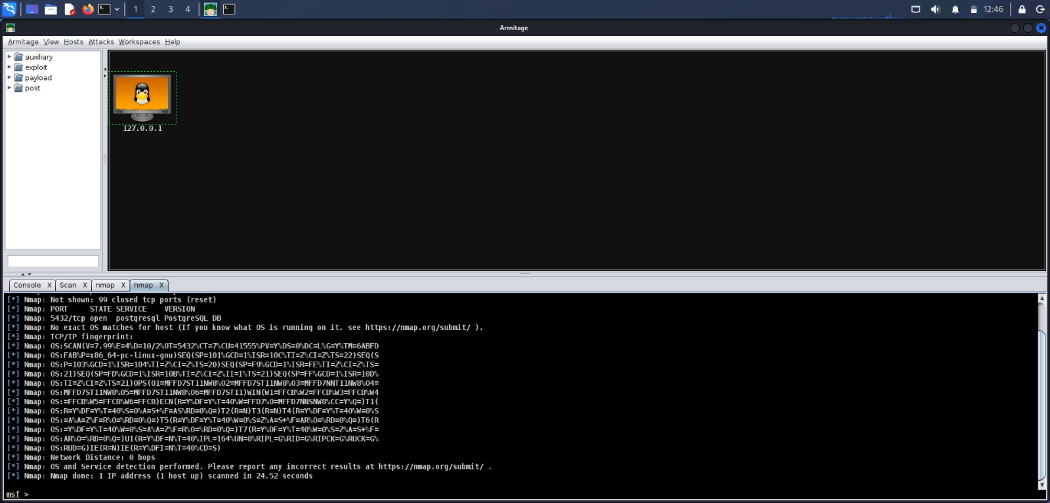
Nmap OS and service detection results for 127.0.0.1 (PostgreSQL on 5432/tcp, scan completed in 24.52 seconds)

Result / Learning Outcomes
- Explained what Armitage is and how it works with Metasploit.
- Installed Armitage and verified it was working on Kali Linux.
- Started Armitage, connected to the RPC server and created a workspace.
- Discovered hosts, used "Find Attacks" and ran an authorised exploit.
- Managed a Meterpreter session and followed the lab safety rules.

